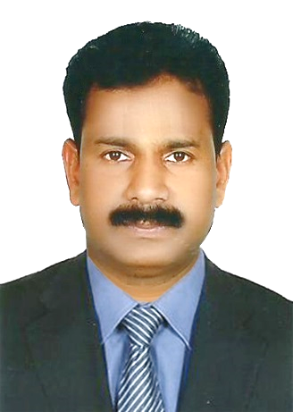
Preman

PROFESSIONAL …………………………………………………..
Though I have acquainted with Purchase background and experience I can explore any type of tasks in related to company’s requirements, irrespective of time and money for the growth of organization.
PROFILE SUMMARY…………………………………………………..
I am a quick-witted and aiming always a sincere supportive to the group or the management in order to achieve goals of firm in a cost effective manner
Contact Me:
C/o-M: +971503718643
E: preman.379370@2freemail.com
CAREER SUMMARY…………………………………………………….
- More than 10 years of experience in various facets of procuring, hiring materials and equipment from national and international markets.
- Experienced with inviting and allotting tenders.
- Experienced in freight clearance procedures and documentation.
- Working knowledge of Orion ERP.
KEY SKILLS……………………………………………………………….
MATERIAL PURCHASE
- Procurement of materials globally.
- Control of cost saving i.w.o. comparison/negotiations with vendors.
- Liaise with inter department for minimize costs
- Confidentiality management.
SUBCONTRACTOR MANAGEMENT

- All types of Equipment hire including development of new vendors
- Evaluate vendors and negotiate with them.
- Team leader to guide inventory /warehouse stock & cost saving way
- Hire subcontractors for major projects.
- Managing contracts for hourly jobs or lump sum jobs.
WORK EXPERIENCE……………………………………………………..
PURCHASER
– Thong Yong Ship Repairing LLC, Dubai, UAE(Sep 2014 to Aug 2017)
- Was independently handling the whole purchase dept. without hassle
- Negotiate with all subcontractors and vendors to timely supply and credit facility

SR. PURCHASE ASSISTANT
– Arab Heavy Industries PJSC(AHI), Ajman, UAE (Keppel Group, Singapore)
(2006 –2014)
- AHI is the first shipyard in the middle east with a capacity of accommodating vessels up to 40 nos for medium type vessels and I was handling all service contracts and subcontractor agreements.
- Arranging service engineers and sourcing original parts from the manufacturer globally as per Production requirements

ACADEMIC QUALIFICATIONS…………………………………………..
- Bachelor of Commerce – B.com (1986)
COMPUTER SKILLS………………………………………………………
ORION ERP (Purchase, Inventory modules), Tally ERP, MSWindows XP/7, MS Office, Internet
LANGUAGES KNOWN…………………………………………………….
English, Hindi and Malayalam
PERSONAL INFORMATION……………………………………………...

Visa status : Visit
Date of Birth : 05-05-1965
Sex : Male
Nationality : Indian
Marital Status : Married
UAE Driving License : Yes.

