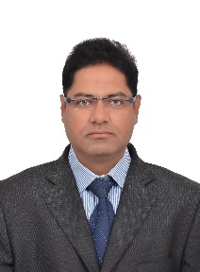
Shahid PMP®
+971 501685421
Dubai, UAE
- shahid.379376@2freemail.com

PROFESIONAL PROFILE

- PMP Certified Civil Engineer Approved from Dubai Municipality and Sharjah Municipality with more than 12 years’ experience in High rise Building Construction, Luxurious Villa, High end Interior Fit out Works & RCC Structural Works, Project Planning, Cost Estimation, Large scale building project experience, excellent technical & Maintenance work knowledge.
- Oversee all on-projectsite activity to ensure projects are completed on schedule, within budget, and in accordance with engineering design. Managing project, Planning and resource utilization. etc.

AREAS OF EXPERTISE

- Project Team Leadership
- Efficiency Improvements On SiteOperations
- Quality Management And reporting
- Health And Safety
- Communication And Influence
- Negotiation & Controlling
- Motivating Staff To Set Target
- Contractor Management

ACADEMIA

- Bachelor Degree in Civil Engineering from Marathwada University, Aurangabad, India (2006)
- Well versed in Primavera, MS. Project, Microsoft word & Excel.
- CAD Tools: Auto CAD 2015
- Operating Systems: MS Office 2015, Windows 9X/ 2015 /XP,

INDUSTRIAL EXPOSURE

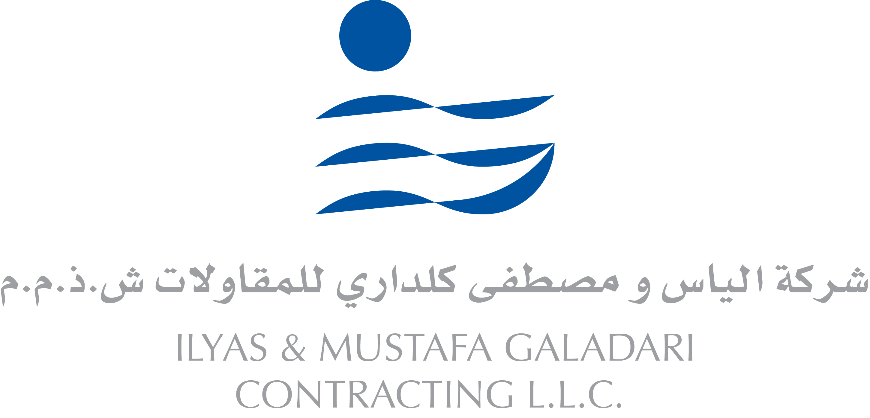
- ILYAS & MUSTAFA GALADARI CONTRACTING LLC
Senior Project Engineer (Dec.2015 – Present)
Key Projects: 1) Construction of 270 Nos.Twin Villas with Basement, Dubai land, Dubai.
2) G+4P+31Floor Residential Tower, Dubai land, Dubai
- Oversee and manage all site operations from Initiating demarcation work up to the obtaining of Completion Certificates from DM.
- Manage engineers, a group of workers, Sub Contractors & allocates tasks to relevant personnel and recruit a team when the need arises.
- Provide comprehensive day-to-day field supervision. Ensure all construction activities are being carried out to quality standards in compliance with the Tender/Contract Documents, budget and schedule.
- Manage the materials requisition, submittals review and approval process. Document all approved materials in line with all internal/external stakeholder requirements.
- Determine labour, Material, Machineries requirements and dispatch of works to construction sites.
- Maintain communications and liaison with all concerned governmental/regulatory authorities, utilities and relevant third parties throughout works construction. Expedite on-going approvals required from the same during/at end of construction.
- Negotiate terms of agreements, draft contracts and Obtain all necessary NOC’s, Permits, licenses, completion certificates, approvals & permissions for construction from Dubai Municipality or appropriate authority.
  - Accurately estimate material, construction and labor costs as well as project timescales
- RICHMOND GENERAL CONTRACTING LLC. Dubai
Project Engineer (Nov.2012 – Dec.2015)
Key Projects: 1) G+2P+21 Storey Residential Tower at Al Nahda, Dubai
2) Construction of Presidential Guard ETS Building for Military Command Works with TABREED At Mahawi, Abu Dhabi
3) B+G+1 Luxurious Villa with Indoor Swimming Pool at Al Khwaneej,
  - Monitors in collaboration with PMT, (Project Management Team), all site construction activities to ensure the projects are accomplished within the prescribed time frame and budget parameters.
  - Coordinate and communicate between Field, Designers, Consultant and Client.
  - Maintain accounts, variations, payments, billing of subcontractors and to prepare Cash Flow Chart.
  - Assess and reviews the project Key Performance Indicators to determine accurate status of project, making tactical decisions for allocating resources, and assigning staff requirements, to maintain project on target.
  - Prepares reports for corrective actions if project becomes behind schedule or overspends budget, and presents to General Manager with recovery plan.
  - To conduct Quality check of concrete, precast structures, Finishing and render assurances on various Engineering materials related to the projects.
- SARH BUILDING CONTRACTING.CO. LLC, DUBAI,UAE
Project Engineer (Mar.2009 – Oct.2012)
Key Projects: 1) 2B+G+7 Residential Building Mankhool, Dubai.
2) G+1 Villa at Al Warqua and Mirdif,
- Monitoring, Commissioning and supervising of all construction activities as per Specifications and DUBAI MUNICIPALITY requirements. Identify and implement corrective action as appropriate.
  - Schedule the project in logical steps and budget time required to meet deadline.
  - Supervise Site operations and maintenance activities at project site and ensure compliance to design specifications and safety requirements.
  - Preparation of Bill of Quantities, Variations and preliminary cost evaluation reports.
  - Review project program and update on a regular basis.
  - Establishment and responsibility for project communication with client and consultant.
  - Coordination and preparation of project close out, review and evaluation report.

- LIBERTY INVESTMENT CO.LLC, SHARJAH, UAE
Project Engineer (Client Representative) (Dec.2007 – Feb.2009)
Key Projects: 1) G+1 Office Building, Workshop and service center at Dubai Investment Park, Dubai.
2) G+1 Villa with swimming pool at Al Qarain, Sharjah
- Inspect project sites to monitor progress and ensure conformance to design specifications
And safety or sanitation standards, Pre-commissioning activities, and assistance to start-up project.
- To ensure that the technical and contractors are adhering sufficiently to the project specification.
- To ensure that the technical and contractual requirements are meet at project site.
- Review Material and technical submittals, Logs and other construction documents.
- To Attend, or conduct, construction meetings with contractor, Consultant, and major subcontractors that are on site.
- Develop and implement a facility management program including preventative maintenance and life-cycle requirements.
- plan and manage facility central services such as reception, security, cleaning, catering, waste disposal and parking
- To provide facility management to shareholders property.

PERSONALPROFILE

Date of Birth: 1ST June, 1979
Marital Status: Married
Languages Known: English, Urdu, Arabic, Hindi and Marathi,
Dubai Municipality Approval Qualified
Society of Engineers UAE Lifetime Member
Visa Status: Employment Visa

