Mahmoud
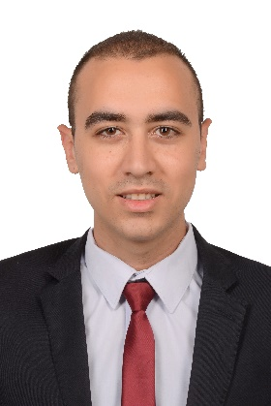
mahmoud.379406@2freemail.com

Summary

A fresh graduate from civil engineering department, faculty of engineering, Suez Canal university. Studied structural engineering with a graduation project in steel structures (Pipe-Arched-Truss Airport terminal). Was elected as the president of Suez Canal university students’ union 2015-2017.

Experience

Civil Site Engineer at El Ahram Company for Engineering & General Contracting
Feb 2018 – Present(3 months)
Cairo, Egypt

Civil Site Engineer at Amar Misr Consultant
Sep 2017 – Jan 2018(5 months)
Cairo, Egypt

Construction engineer intern at Engineering Authority of the Armed Forces
Jul 2016 – Aug 2016(2 months)
Ismailia, Egypt

Civil Engineering Internat National Company for General Contracting & Supplies
January 2014–January 2016(2 years)
Ismailia, Egypt
- Assists with construction observations, reporting and materials testing and monitoring contractor’s compliance with contract documents.Assists in the review of design documents and reports

Civil Engineering Internat the Arab Contractors
June 2014 -September 2014 (4 months)
Ismailia, Egypt

Volunteer Experience

President at Suez Canal University Students' Union
November 2015 – August 2017 (1 year 10 months)

Presentation Team member at Enactus
March 2015 –May 2017

President at Nothing Impossible Team
April 2012 –August 2016
Education
Suez Canal University
Civil Engineering, 2012 - 2017
Grade: 2.4, C+
Graduation Project/Grade: Steel project (Arched Airport terminal) / 3.7, A-
Activities and Societies:
University Students’ Union president.
Horizon Family member.
Nothing Impossible Family leader.
Takatof SCU family PR member.
Enactus Ismailia presentation team member.
Student Activities consultant.
The representative of 6000 students at Universities Youth Week 10 in 2015 and gave the students speech in front of the President Abdel Fattah el-Sisi.
Students Committee Manager at the 7th Students Activities Forum 2017.
Member of the Board of Directors of Quality Assurance Center at Suez Canal University 2016-2018.
Interests and Hobbies
Civil Engineering, travelling, learning new cultures volunteering, public speaking, human resources management, organization development, football, photography, writing, sand boarding.

Skills
- Technical skills
AutoCAD 2017 (Intermediate)
SAP 2000 (Intermediate)
MS Office (Advanced)
Revit 2018 (Novice)
Advance Steel 2017 (Novice)
- Soft skills
Communication
Problem Solving
Management
Coping with pressure

