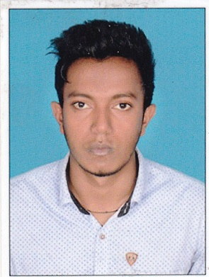

SANDEEP

Email: sandeep.379466@2freemail.com

Education

2014 – 2016: MBA (finance & MARKETING) FROM BANGALORE UNIVERSITY, KARNATAKA, INDIA.

2011 – 2014: BBm (bachelor of business management) FROM KANNUR university, KERALA, INDIA

2009 – 2011: PLUS TWO (12TH) commerce FROM KERALA STATE EDUCATIONAL BOARD, INDIA

2009: 10TH FROM KERALA STATE EDUCATIONAL BOARD, INDIA

Experience
- Worked as a Accounts assistant in Mastro Metals pvt ltd, Payyanur for a period of 1 year.
Responsibilities:
  - Preparation & finalization of accounts, preparation of financial statements.
  - Preparation of monthly financial statement & report.
  - Review and verify the accuracy of reported data.
  - Review of expense accounts payable and accounts receivable.
  - To take financial advice from the respective person.

Academic Projects Undertaken

Company: DENNIS MORTON, Kerala, india.
(INDUSTRY: MANUFACTURING)
This project is done for the purpose of studying in detail about the complete functioning of Dennis Morton, the manufacturing of shirts. It is done to know the process and product layout of machineries, budgeting; cargo enquiry etc. company does the complete work starting from raw material handling and dividing it into different department for further process and finally exited as a final product with a good quality.

Company: NANMA FOODS, Kerala, india
(INDUSTRY: FOOD PROCESSING)

This project is done for the purpose of studying effect of travelling distance and population density on locations of super bazaars with respect to NANMA retail chain.

IT Credentials:
- Proficient in working on MS Office (windows XP, Windows 2007, 2010, etc.)
- Knowledge in TALLY

Skills Set:
- Strong problem solving skill to resolve issue quickly and fairly.
- Excellent presentation skill.
- Ability to deal with people.
- Willingness to learn.
- Good analytical skill.

Achievements:
- Participated in "Cancer Awareness Walkathon 2015, Bangalore"
- Participated in the student conclave 2016 on the theme "Dissertation Guidelines - Ideation to Execution"
- Coordinator for Euphoria 2012 & 2013 – an inter-college fest
- Arts club coordinator at college

Hobbies & Interests:
- Traveling (long drives).
- Music, Movies, Sports Events, etc
- Playing Badminton & Football.

Personal Details:
Nationality : Indian
Date of Birth : 06/11/1993
Gender : Male
Marital Status : Single
Languages know : English, Hindi, Malayalam, and Tamil.

Declaration:

I hereby declare that the above furnished details are true with proven records.

