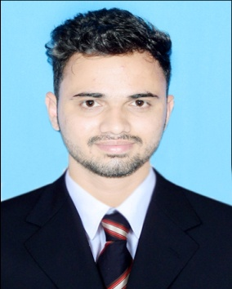
Inam
Bachelor in Management Studies (BMS)

inam.379476@2freemail.com

SUMMARY
- Profile: | Male , 23 , Single
- Nationality: | Indian

PROFESSIONAL EXPERIENCE

- S.H. PARKAR & ASSOCIATES (CHARTERED ACCOUNTANTS)
MAY 2017 - FEBRUARY 2018
- Roles and Responsibilites undertaken:
- Handling customer’s accounts.
- Handling accounts payables and receivables.
- Conducting internal and statutory audits.
- Maintaining important documents and reports.
- Managing clients banking transactions.

EDUCATION

2017 Bachelor in Management Studies. Maharashtra, India
Mumbai University

2012 | H.S.C.  Konkan Board | Maharashtra, India
2010 | S.S.C.  Kolhapur Board | Maharashtra,India
OTHER CERTIFICATES

2010 CCC Maharashtra, India

2017 | ADVANCE EXCEL | Maharashtra, India
ACHIEVEMENTS-ACADEMIC AND EXTRA CURRICULAR INITIATIVES:
- Represented college in zonal level cricket tournament.
- Was selected in baseball national tournament camp.
- Actively participated in all the college events.

STRENGTHS AND POSITIVE ASPECTS:
- Leading, coordinating and co-operating well with a team.
- High level of flexibility at the work place.
- High grasping power.
- Always enthusiastic to learn new things.
- Proficient in managing operations.
- Focused, logical, responsible.

PERSONAL INFORMATION:

Date of Birth: 27-02-1995
Gender: Male
Marital Status: Unmarried
Nationality: INDIAN
Languages Known: English, Urdu, Marathi and Hindi

