CURRICULAM VITAE

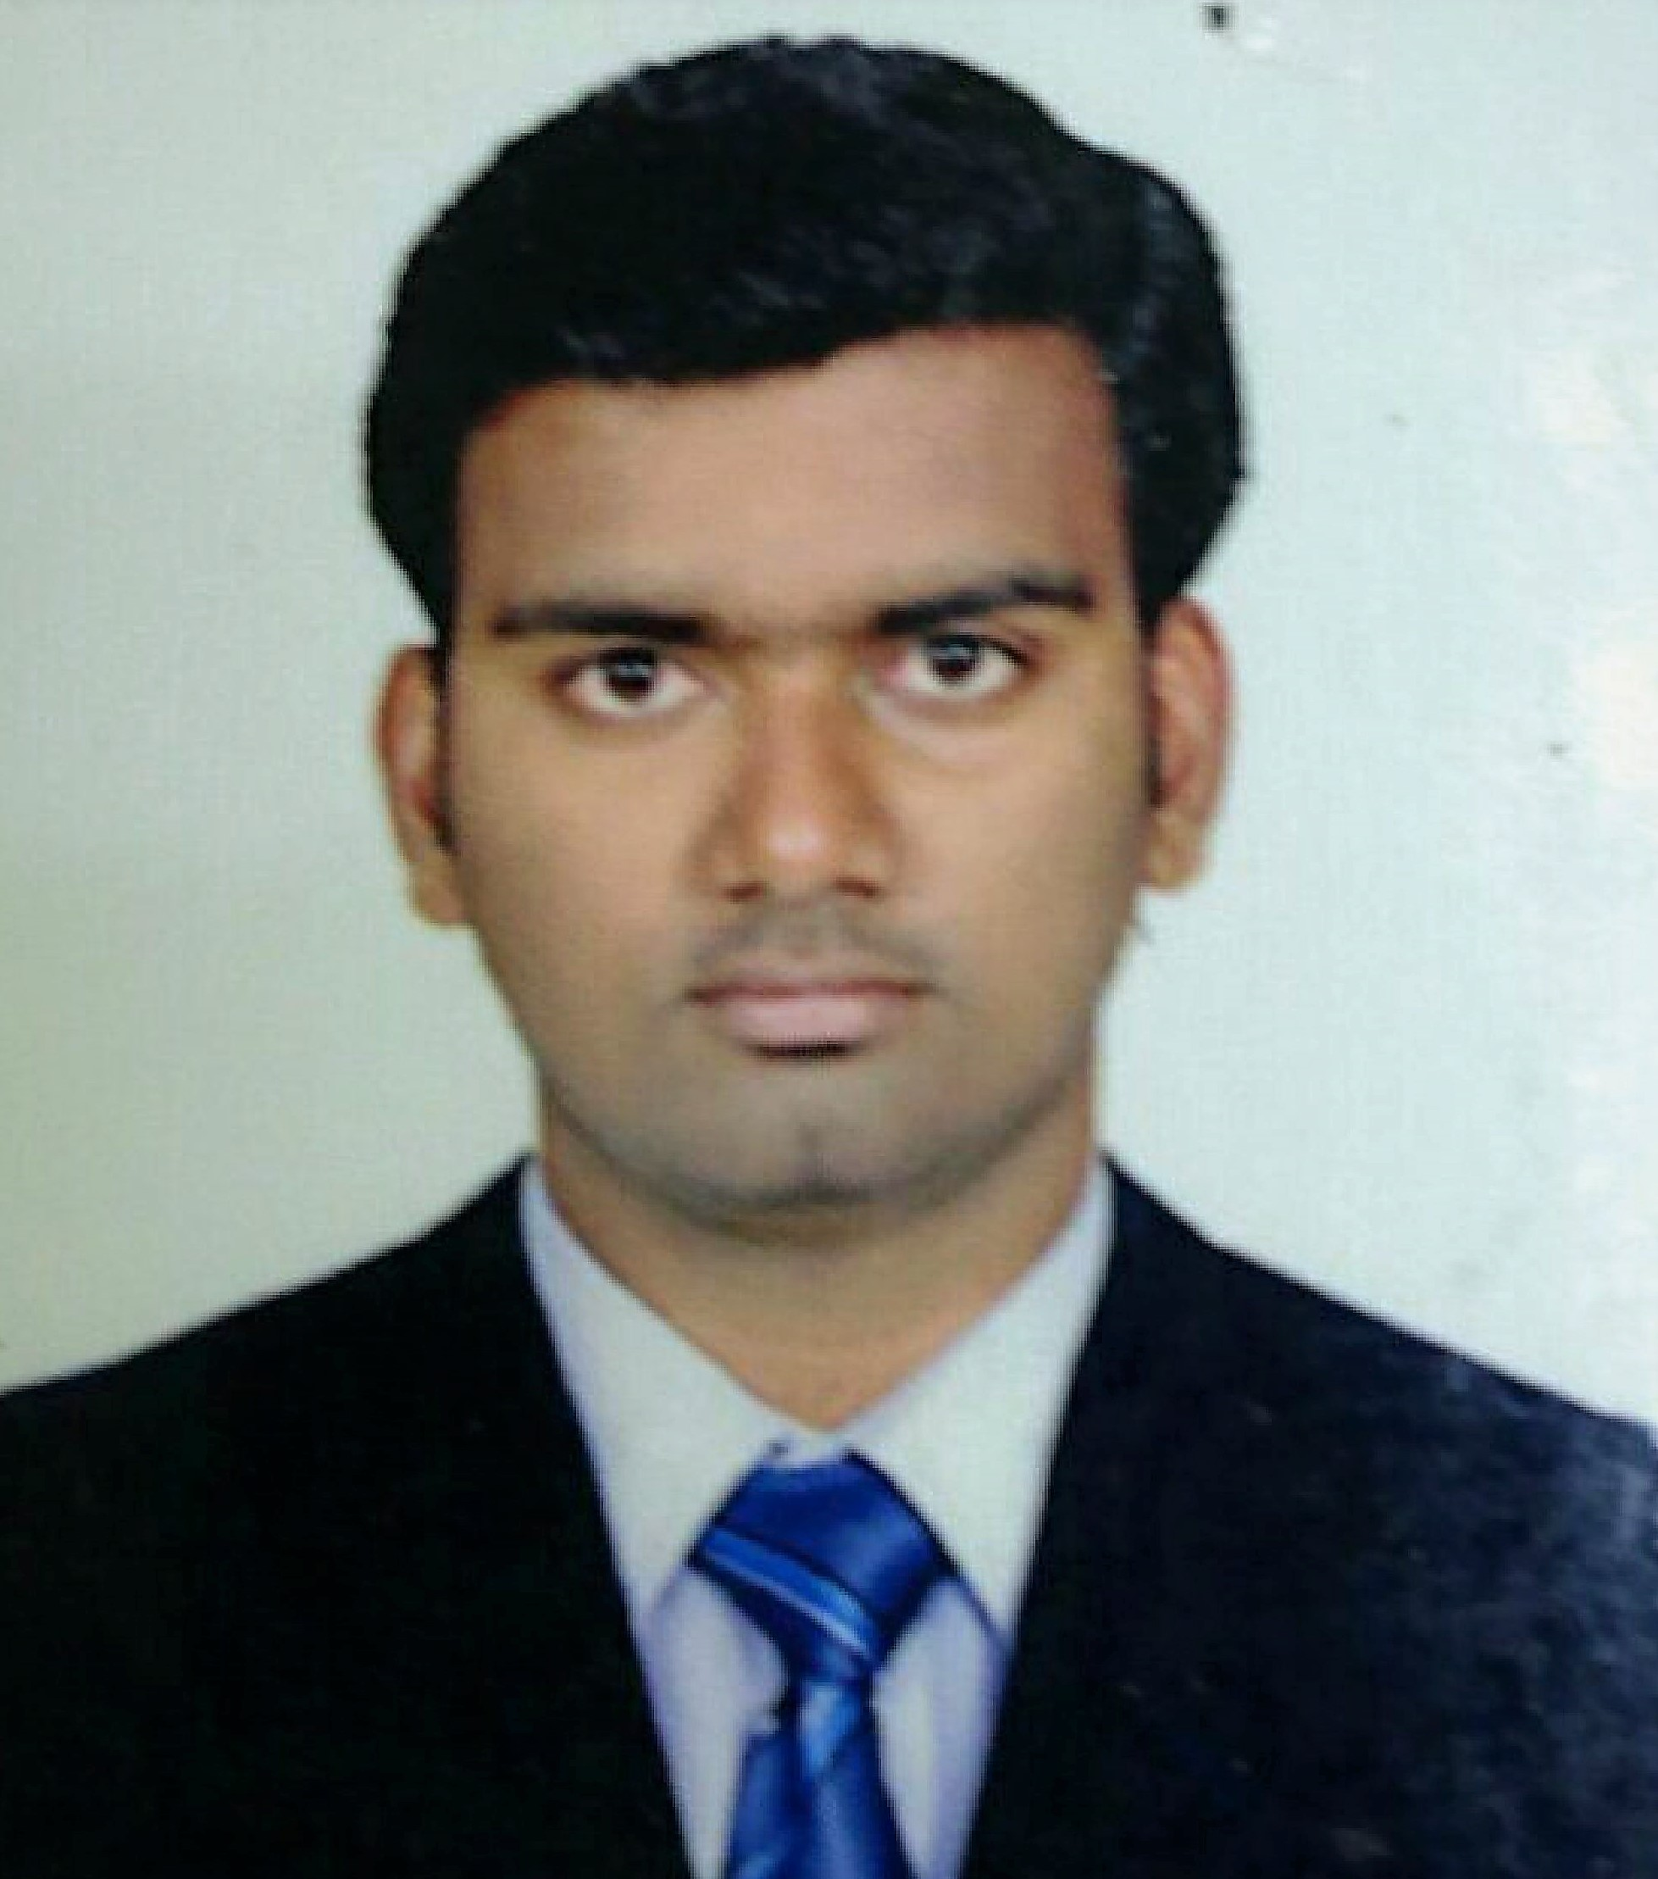

KARTHIK

CONTACT INFORMATION

Karthik.379488@2freemail.com

EDUCATION

- Bachelor of commerce / 2005-2008 batch / CBM college / Bharathiyar University / Coimbatore

- Higher secondary / 2003-2005 batch / TNGR higher secondary school / Coimbatore

- SSLC / TNGR higher secondary school / Coimbatore

SKILLS
- Microsoft Word
- Microsoft Excel
- Facts accounting software
- Tally accounting software
- Microsoft outlook

PROFESSIONAL PROFILE
Accountant with 9+years of experience in junior level to senior
level. Ensuring accurate reporting of accounting information to
the management and maintain the accounts with accounting
principals. Handling the accounts individually up to finalization
without supervising.
EXPERIENCE SUMMARY
ACCOUNTANT
Tawoos agricultural UAE LLC / Dubai / 2014 – Present
Duties and responsibilities
- Invoicing.
- Preparation of VAT.
- Receivables and Payable management.
- Preparing the payment request for suppliers.
- Inventory controlling.
- Bank reconciliation.
- Passing the purchase, sales, journal vouchers
- Issuing the Debit note and credit note
- Handling the Branch accounts individually.
- Preparing monthly reports to the management.
- Bank activities.
- Monitoring the utility bills and settle the dues before the due date.
- Cash handling.
- Book keeping.
- Monitoring the co-workers work and correct their mistakes.
- Budget forecasting.
ACCOUNTANT CUM ADMIN
Synetics Automation Solutions Pvt LTD / Coimbatore / 2013-14 Duties and responsibilities
- Invoicing and book keeping
- Maintaining the receivable and payable
- Bank reconciliation
- Preparing monthly reports to the management.
- Handling the admin activities like attendance, payroll, salary distribution etc.
- Filling VAT returns through online.
- Preparing the central excise and C-Form
- Handling the petty cash.
JUNIOR ACCOUNTANT
Suryabala Autos Pvt LTD / Coimbatore / 2008-2012
Duties and responsibilities

- Invoicing and book keeping
- Bank reconciliation
- Purchase order processing
- Preparation of VAT and Service Tax
- Handling cash
- Co-ordinate with Auditor for Tax filling and sales tax office works.
- Bank works
- Stock Auditing

ADDITIONAL QUALIFICATION

- Software - DOA (Diploma in office automation in IMF computer education)
- Packages - Ms-Office
Tally (9.0 ver.)
LANGUAGES KNOWN

- Tamil, English [ Read, Write and Speak ]
- Malayalam, Hindi[ Speak only ]

PERSONAL INFORMATION

Gender : Male
Marital status : Married
Age & DOB : 30years, 02.12.1987

DECLRATION
I am here by declaring all the above information’s are true by my knowledge.

