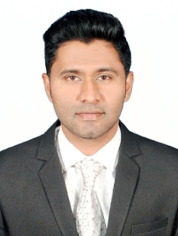
CIRRICULAM VITAE

Nouman

E-mail: Nouman.379508@2freemail.com

Career Objective
To acquire a demanding position in an environment where i can best utilize my skills and education for the growth of the organization.

Work Experience

- Worked as an C.R.O Airtel Voice Process in Hinduja Global Solutions. From 27th January 2017 to Till 11-02-2018.

Score
SL No. | Name of Degree | Name of the Institution | Board/  University | Year of Passing | % of Marks
1 | B.B.M (Finance) | V.V.F.G.C, Mysore. | Mysore University | 2015 | 50.00
2 | P.U.C | VidyaVikas PU college,  Mysore | Pre-University Board | 2010 | 41.00
3 | S.S.L.C | Anita High school, Malavalli. | K.S.E.E Board | 2006 | 45.00

Hardware skills
- JCHNE (JETKING)
- Hardware, operating system,Networkingessentials,Windows Server 2008,
- Linux and CCNA
- Knowledge of Microsoft office word and Power point.

Hobbies
- Internet Browsing
- Playing Cricket
- Traveling
- Listening to music

Passport Details
- Date of Issue : 08-01-2018
- Date of Expiry : 07-01-2028
- VISA Status : VISIT VISA
Personal detail
Date of Birth : 29thNovember 1990
Nationality : Indian
Marital Status : Single
Languages Known : English, Hindi, Urdu and Kannada

Strength

Optimistic approach, Analytical thinker, Urge for learning, Quick at grasping, Creative, Effective communicator, Smart worker.

Declaration

I hereby declare that the above information furnished is correct and true to the best of my knowledge.

