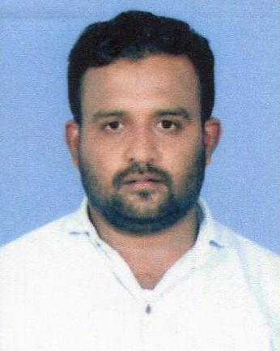
BASHEER
Email: basher.379562@2freemail.com
Dubai, U.A.E.

OBJECTIVE

To seek challenging career in a fast place organization where my experience commensurate together with my creative approach with can contribute to its long term goals there by helping to strength my professional skills. I acquired throughout my career.

PERSONAL DATA

Nationality : Indian
Sex : Male
Civil Status : Married
Place of Birth : Kerala
Date of Birth : 18/05/1983
Visa Status : Tourist Visa
Languages : English, Hindi, Malayalam, Kannada, Arabic basic

WORKING EXPERIENCES

- Worked 1 year as Sales at Emirates Marketing and Promotions, Dubai – UAE.
- Worked 3 years as a Cashier at M.K National Store, Mumbai – India.
- Worked 3 years as a Waiter at Obroy Restaurant Mumbai – India.
- Worked 2 years as a Room Boy at Imperial Hotel Bangalore – India.

PERSONAL STRENGTHS

- Collect Cash from the Customers
- Manage daily payments to the clients
- Make a clear summary of total sales
- Can able to work under pressure
- Providing professional customer service
- Highly motivated and hardworking
- Has the strength to build relationship closely with others
- Excellent interpersonal/human skills
- Honest, disciplined and dedicated
- Ability to pay close attention and maintain confidentiality
- Interested in a long term career
- Provides and serve all guest what they need
- Handle customers
- Preparing and giving them a good service

- Maintaining relationship with prospective clients
- Responsible for inquiries and provide effectively to reach clients satisfactory

EDUCATIONAL ATTAINMENT

- Exam : PUC – 2nd Year
Institute : Thriveni College, Kasargod, Kerala – India.
- Exam : S.S.L.C.
Institute : Sheni, Kasargod, Kerala – India.

DECLARATION

I hereby declare that the above particulars furnished by me are true and correct to the best of my knowledge and belief.

