CURRICULUM VITAE

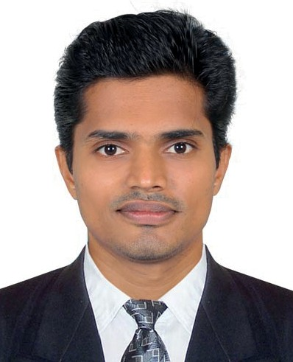AKHIL
ACCOUNTANT

Dubai, UAE
Email : akhil.379573@2freemail.com

CAREER OBJECTIVE
Seeking a suitable position in Accounts & Finance with a reputed organization, where my education, experience and hard working can contribute to the enrichment of myself and growth of the organization.

PROFILE
Handling and maintaining accounts up to Finalization VAT Taxation
Manuel & Computerized Accounting

Receivables & Payables
Inventory Management with VAT

Proficient in using Tally ERP 9, MS Office
Have excellent communication & interpersonal skills

EDUCATIONAL QUALIFICATIONS

M.B.A - ( Mahatma Gandhi University, Kerala, India) B.Com - ( Mahatma Gandhi University, Kerala, India)

IT SKILLS

Thorough working knowledge in computerized environment Systems involving Microsoft Office Packages
Accounting packages – Tally ERP 9

WORK EXPERIENCE
Organization : M/s. ACCOUNTS
(Accounts contractors provide high quality and specialized accounting services to various industries)

Location : Cochin, Kerala, India
Nature of Work : Manual & Computerized Accounting Position : Accountant
Period : From 13th June 2012 to 26th February 2018
Reference : P.V. Paulose (Administrator)
M/S Accounts : +919447840464

RESPONSIBILITIES
Compile and analyze financial information’s and documents to prepare books of accounts and its finalization.
Maintenance of Day Book and ledgers

Maintain Cash and accurately record cash transactions. Prepare Income Statement and Balance Sheet
Preparation of cash flow and fund flow statements

Payroll preparation and Accounting
Preparation of Purchase and Sales registers. Monitoring Payables and Receivables
Produce monthly statement of accounts.

Preparation of Bank reconciliation statements Inventory with VAT

PERSONAL INFORMATION

Date of Birth : 20th August 1989

Gender : Male

Nationality : Indian

Marital Status : Single

Religion : Christian

Languages Known : English, Hindi,Tamil, Malayalam

DECLARATION
The above information provided is correct to the best of my knowledge and belief. I shall be grateful if you provide me the chance to work with you. I shall work to best of my abilities and your expectations.

