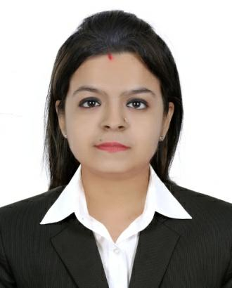
Resume

Pooja

Dubai,(U.A.E)

E-mail: pooja.379590@2freemail.com

Objectives

ToobtainaresponsiblepositioninasupportiveenvironmentwhereIcanhelpthe organizationgrowinvalueutilizingmyexperience,capabilitiesandabilities.

Professionalexperience

VijayRajMedical&SurgicalBhopal.INDIA. 2013to2017

Role-Cashier&DataOperator

- Makingabilandtakingcashfromcustomers.

- Maintainingalistoflowavailability&OutofstockProductsandFolowingupto bossregardingorderingofRequiredProducts.

- Enteringastockinsoftwarethroughpurchaseorder.

- Maintainingandkeepingasharpeyesonlistofshortexpiryandslowmoving Products.

- Atendingacustomerintheabsenceofstaff.

- Makingendofthedaysalesreporteverynextmorning.

- HandlingatendanceandsalaryAccountsofstaff.

Relevantexperience

- ExperiencedtoworkwithanysoftwareincludeMsWord,ExcelIncludeonline

Search.

- Abletoworkinateamwithagoodteamspirit.

PersonalInformation

• DateofBirth | - | 14–May-1991
• Status | - | Maried
• HomeTown | - | Indore(MadhyaPradesh)INDIA
• Nationality | - | Indian
• Language | - | English,Hindi&Sindhi
• PassportissuePlace | - | Bhopal
• Typingspeed | - | 80wpm

EducationalBackground

- GraduateInBachelorofBusinessAdministrationFromBarkatulahUniversity BhopalIn2013,INDIA

ComputerSkils

- BasicandMsOfficeCourseFromExcelentComputerInstitute-2013

Strength

- Abletomaintainagoodcommunicationwithclients&Coleagues.

- Positive

- Canperformunderpressure.

Reference

- Availableifrequired.

Declaration

Idoherebydeclarethataltheinformationgivenaboveistruetothebestofmy

