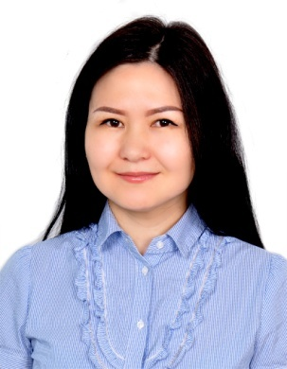
Curriculum Vitae
PERSONAL DETAILS:
Name Zhibek
Date of Birth 15.11.1987
Nationality Kyrgyzstan, Bishkek
Email zhibek.379624@2freemail.com
Address Ajman, UAE
Material status Single
Visa Status: Visit visa

Career Objectives: My goal is to become associated with a company where I can use my skills and gain further experience while enhancing the company’s productivity and reputation. I concede myself to be a willing worker and I am always confident that I can accept challenging assignments and achieve result.

EDICATION:

2005-2009 Finance and Credit Department.
Kyrgyz Economic University, Bishkek, Kyrgyzstan

SKILS
MS Word, Excel,
Strong verbal and personal communication skills
Tolerant and flexible to different situations
Adaptability and ability to work under pressure
Sales ability
Take responsibilities

Work Experience

Company name Multiplast Trading LLC. "Lanvin & Kid Space" Dubai mall

Position Title Sales associate, cashier
Location UAE Dubai, Dubai mall
Duration From September of 2015 to November 2017
Responsibilities
- Providing customer service by assisting and acknowledging customers, maintaining outstanding standards.
- Ensure that each customers transactions are processed accurately and in a time efficient manner
- Preparation of Daily Sales Reports:
- Statement of cash receipt in local currency and foreign currency
- Report of non cash, report of exchange, refund (dummy, credit, cash, gift cards etc.)
- Excellent communication skills to build up relationships with customers.

- Offering advice on products and services, and helping with product selection.
- Effectively managing stock levels.
- Using every opportunity to maximize sales opportunities.
- Ensure that all items are appropriately displayed on the shelves and oversee maintenance of store
- Resolve employee conflicts and ensure that any customers complaints are handled immediately

Company name Royal Catering Services, Restaurant D'Alsace
Position Title Hostess, waitress
Location UAE Abu Dhabi, Yas Marina
Duration From October of 2014 till September of 2015
Responsibilities:

- Greet customers in a friendly and warm welcoming manner when entering restaurant
- Present menu and take order
- Made sure all food was nicely prepared
- Made sure that every customer was taken care of properly at the cash register
- Made sure the environment was a clean and friendly place so that customers would want to come back.

Boutique "Mango”
Position Title Sales Executive
Location Moscow, Russian
Duration From 2011 to 2013
Responsibilities:
- Greeting warmly, Excellent communication skills required to build up relationships with customers.
- Offering advice on products and services, and helping with product selection.
- Formation of contract with clients
- To provide excellent customer service
- Consultation customers on company goods
- Track replenishment and consumption of warehouse inventory;
- Resolution of conflict situations with customers

Company name Grand Hotel
Position title Hotel Front Desk Receptionist
Location Bishkek, Kyrgyzstan
Duration 2009-2011

Responsibilities
- Greet and assist visitors and guests arriving on front desk
- Answer phone in a friendly and helpful manner
- Take payments through cash, credit and debit cards
- Maintain confidentiality of hotel data and guest information

Languages : Kyrgyz native, Turkish, Russian-fluent, English-fluent

