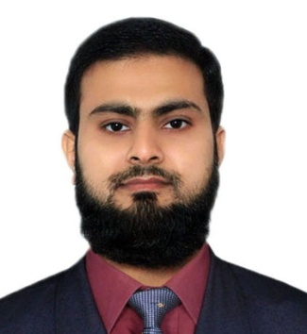
Curriculum Vitae

FAKHAR

Personal Information:-

Date of Birth: 01-09-1987
Citizenship: Pakistani
E-mail: fakharzafar7@gmail.com
Visa Status : Employment
Driving License : UAE valid driving license
Religion: Islam
Marital Status: Married

Academic Qualification:-

Certificate / Degree | Year | Board / University
Masters In Mass Communication (MA) | 2009-2011 | Bahauddin Zakariya University  Multan – Pakistan.
Bachelor of Arts (BA) | 2007-2009 | Bahauddin Zakariya University  Multan – Pakistan.
Diploma in Business Administration (DBA) | 2005-2007 | Petroman Training Institute  Multan - Pakistan.
Secondary School Certificate (SSC) | 2001-2003 | Board of Intermediate and Secondary Education Multan-Pakistan.

IT Skills:- Languages:-
- MS Word, Excel and PowerPoint English
- MS windows Urdu
- Internet & email Punjabi
- Social media marketing Saraiki

Experiences:-

1) Customer Relationship Officer
VIP Travel and Tours (1-12-2012 to 15-12-2013)

Duties & Responsibilities:
- Visiting corporate customers for introducing travel packages
- Issuing and modifying tickets to customers
- Maintaining accounts
- Making calls and getting feedback
- Processing visas and preparing necessary documentation

2) Sales Manager
See & Select Mobiles (1-1-2014To 30-9-2017)

Duties & Responsibilities:
- Arranging promotional activities
- Launching campaigns to grab customers
- Designing newspaper advertisement
- Bridging gap between customers and salesman
- Fixing after sales issues
- Conducting trainings and provide guidelines to salespersons for boosting sale

3) Sales Representative
JKF Garments Trading LLC Dubai (Currently working)

Duties & Responsibilities:
- Visiting Customers
- Booking and delivering orders
- Maintaining accounts
- Preparing daily sales reports

