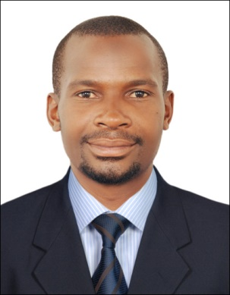
NAME: KALULE.
NATIONALITY: UGANDA.
VISA STATUs: VISIT VISA.
DATE OF BIRTH: 02-NOV-1986
EMAIL: kalule.379676@2freemail.com

SAFETY OFFICER
Professional Summary
Thorough Construction Safety Officer who is certified by IOSH/NEBOSH and several local and state safety agencies. Adept at developing safety plans for any location working closely with field management to maintain safety and staying up to date on all safety requirements. Specializes in commercial and industrial construction projects.

Core Qualifications
- Maintaining a sounding safety record(ZERO HARM)
- Able to work in any kind of conditions
- Able to climb high structures and work in enclosed areas
- Strong computer skills
- Good knowledge of OSHA safety standards
- Dedicated to maintaining safety discipline on worksite
- Good communication and presentation skills for field personnel
- Installation technician(CCTV cameras)
- Excavator operator
- Forklift operator
Experience

JOVIAL TRADING AND CONTRACTING 2016 – TO DATE
Construction Safety Officer- Muiather, Qatar
- Giving safety induction training
- Monitor and raise the safety performance of the workers
- Identification & prevention of Hazards in site on a daily basis
- Conducting Tool Box Talk for workers with various topics (TBT)
- Verification of Personal Protective Equipment (PPE)
- Issuing and Verification of work permit system like hot works Confined space entry
- Ensure safety in work at height (WAH)
- Conducting and Coordinating of Mock drills like fire drills.
- Inspection and Evaluation of scaffold
- Fire safety, basic firefighting skills and prevention
- Verification of LOTO system
- Safety measurement in confined space entry (confined entry safety)
- Housekeeping and waste disposal
- Oxygen monitoring for confined space
- Finding unsafe action and unsafe conditions
BAYNON CONTRACTING 2015 - 2016
Construction Operator and controller- Doha, Qatar
Operator
- Excavator operator
- Forklift operator

Controller
- Responsible for weekly work site safety reports.
- Worked closely with field management to maintain all safety standards.
- Responsible for doing regular work site inspections.
- Responsible for creating job hazard analysis for construction site.
- Responsible for new worker and equipment safety induction.
- Responsible for work supervision at all time to ensure safety standards
- Making safety signage whole over the site and maintain good understanding of them
DOTT SERVICE 2010 - 2014
Construction operator- Kampala, Uganda
- Machine pre start inspections
- Maintaining a good day to day house keeping
- Report progress needs or other pertinent information to site managers
- Inspect each piece of machine to ensure it is in proper working condition
- Oversee the safety precautions required when using heavy machinery
- Developing and maintaining sites rules.
- Responsible for work supervision
- Heavy equipment inspection
- Making appropriate work reports for machines
- Daily machine checkups
Education
Bachelor’s Degree in Information Technology, Makerere University
Safety awareness course YMCA Kampala, Uganda
Safety certificate – IOSH managing safely
Safety certificate – NEBOSH -DOHA INDUSTRIAL SAFETY SERVICES Doha, Qatar-.

