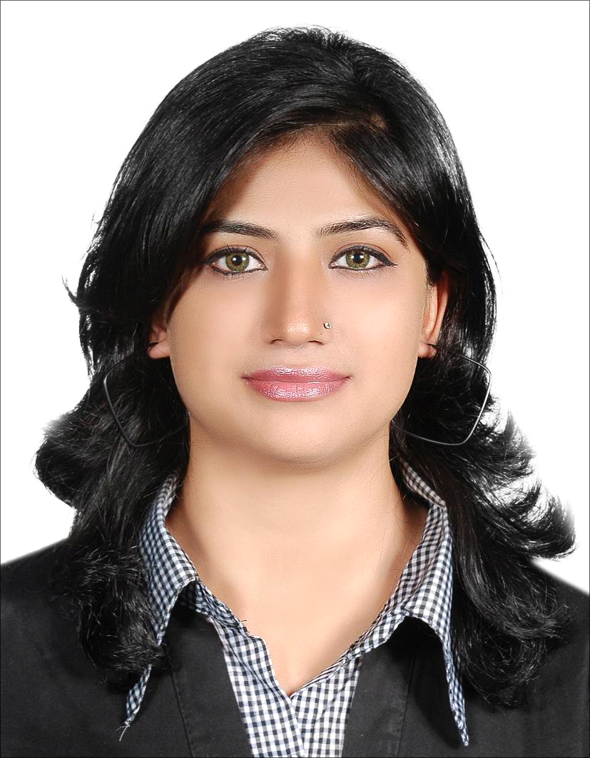 Sabah
United Arab Emirates
Email: Sabah.379688@2freemail.com

Career Objective
Looking for a managerial and administrative position with competitive and challenging environment which offers fast paced growth and development opportunities

Professional Experience
Allied Bank Limited  Teller MG12 May 2009 to till date  Branch Customer Services  Jan's Shopping Arcade  2007-2009  Training & Courses Attended | Key Responsibilities  - Accept retail and/or commercial deposits, loan payments, process checking and savings account withdrawals  - Maintain an adequate cash drawer at all times; this includes buying and selling currency from the vault as necessary.  - Balance cash drawer in accordance with Bank procedures and regulations including periodic batching of cashed checks.  - Assist in ordering, receiving, verifying, and distributing cash.  - May be responsible for bank opening and/or closing.  - Maintains the highest level of confidentiality with all information obtained.  - Represent the Bank in a manner that maintains and expands positive relations with all customers, potential customers and co-workers.  - Perform as a team member in allocating and coordinating the work flow  - Final Balancing / Vault balancing closing  - Preparing daily Cash LCY Boos  - ATM Balancing and Reconciliation  - Arrange fresh currency notes and National Prize Bonds from S.B.P  - Manage bank vaults to ensure correct cash balances  - Transfer funds at the request of clients  - Perform end of the day recap of money and bank slips  - Post all cash and credit card entries into the database  Liability Operations (Clearing & Remittance)  - Processing of FOBCs, USD$ Clearing  - Handling of special projects given by our Manager.  - To Issue Bankers Chq, Demand Draft accordance with the Bank and Local regulations guidelines.  - Payment of BC/DD & Cancellation of BC/DD.  - Accordance with the Bank and Local regulations guidelines.  - Adhere to all policies and processes to ensure an acceptable risk rating of the branch by Audit.  - Ensure all operational transactions are processed accurately and in accordance with the laid down procedures.  - Ensure effective risk management and local regulatory compliance for the branch operations.  - Ensures that customer queries and complaints are resolved in a reasonable time depending upon the nature of the complaint.  - TDR/Fixed Deposit booking and encashment  - Meet and greet customers and manage Floor.  - Route customers to alternate channels such as ATMs/.CDM's/phone banking/Internet banking.  - Receive & accept all types of instructions from customers. Eg: but not limited to OTT’s, Book transfers, Hybrid Instructions, fixed deposit instructions, amendments.  - Deliver liability letters, release letters to customers.  - Help and assist customers use alternate channels such as breeze, Internet banking, CDMs , ATms and phone banking.  - Scanning all types of documents, insurance documents)  - Send e-mails to RM’s/other units in the bank advising details of cheque return.  - Call back to customers (after receiving contact numbers from Tellers / BOM / BOO / TSM / Chief Teller) advising the reason for return of cheques.  - Despatch returned cheques to other units/branches.  - Filing & photocopying and inserting letters in envelopes for mailing.  - Cross Selling of different banking products.  Collection and Accounts Receivable Officer  - Handling accounts receivables and keeping record of payments.  - Collections of cash and making phone calls to debtors.  - Consolidation of customer accounts statement. Emailing.  - Dispatching statements to customers.  - Preparing credit and debit notes for customers.  - Reconciliation of customer accounts.  - Sending Payment Reminders and Follow up.  Conducted by Bank Al-Falah  - Account Opening  - Anti-Money Laundering & Know Your Customer.  - Basic Branch Banking Trainings.
Education | Bachelor of Commerce (2007)  Poly Technical Institute for Woman, Peshawar, Pakistan

Computer Skills | Highly proficient with MS Office (PowerPoint, Excel, Word).working on Win 98, 2000, Me and XP, Windows 7, good knowledge of internet browsing and typing speed: 50 wpm

Personal Information
Marital Status: | Single
Birth Date: | 25 December 1985
Nationality: | Pakistani
Visa: | Long Term Visit

