DINESH

E-Mail: dinesh.379704@2freemail.ocm

FINANCE & ACCOUNTS PROFESSIONAL
An ardent analyst with expertise in strengthening companies to lead in highly competitive situations; versatile, high-energy professional, successful in achieving business growth objectives within turnaround & rapid changing environment

AREAS OF EXPERTISE
Finance & Accounts
MIS & Reporting
Taxation
Cost Management
Statutory Compliance
Reconciliation
Treasury Operations
Liaison & Coordination

PROFILE SUMMARY
- A highly competent professional with more than 10 years of experience in Finance & Accounts.
- Hands on exposure in managing financial accounting, receivables & payables management, preparing ledger books, bank reconciliation statements and finalization of accounts
- Experience in monitoring the issuance of all types of Letters of Credit, Guarantees, LC Confirmations, Transfer of LCs, etc.
- Capable of implementing accounting systems & procedures as per regulatory and legal requirements including taxation, annual report and accounts
- Achievement oriented professional with excellent people management skills and an ability to manage change with ease

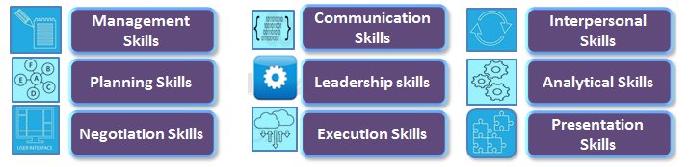
ORGANISATIONAL EXPERIENCE

Since Feb’11 Specialist Services Holdings Ltd., Dubai as an Management Accountant
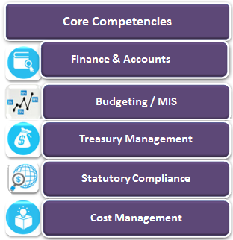
~ Reporting to Group Finance Manager ~

- Supervise and manage the activities of Day to day accounting and maintenance of books of accounts for UK, Cyprus, Singapore and UAE subsidiaries & Joint ventures.
- Coordination for payroll processing and payment of salaries of Subsidiary companies.
- Preparation of PPE Schedule & Insurance reports as supporting to financial statements & annual reports.
- Responsible for handling all fixed assets of the group (UAE & Singapore) and monitoring Capital Expenditure & Budget.
- Responsible to obtain quarterly confirmation on group assets from custodians & auditing such reports for genuineness.
- Preparation and submission of GST & VAT returns for Singapore & UK subsidiaries.
- Preparing Bank Reconciliation, intercompany reconciliation, P&L, Balance sheet & cash flow for subsidiary companies.
- Liaising with insurance brokers for renewal of policies, extension of coverage, pricing of premium & regular endorsements for all group companies.
- Framing procedures & manuals on process relating to assets, insurance & intercompany transactions.
- Helping IT department in developing or customising reports in ERP (Microsoft Dynamics)
- Preparing and finalizing statutory & tax audits with auditors & ensuring all compliances under the regulatory acts and other statutory bodies and submission of corporate tax returns and filings within due date.
- Preparation of Budget, Cash Flow & quarterly forecast of subsidiary companies
- Liaising with statutory & internal auditors for timely completion of audits and implementation of audit observations
- Liaising with UAE tax consultants for the implementation & system change in related to VAT compliance.
- Arranging external training to finance staff & conducting internal training to non-financial departments.
Jul’08 to Feb’11 Rakha Al Khaleej International LLC, Dubai, UAE as division accountant
~ Reporting to Vice President Finance ~

- Day to day accounting and maintenance of books of accounts.
- Preparing Bank Reconciliation Statement & Inter Company Reconciliation at the end of each month.
- Conducting internal stock audit for every three months & submitting all the relevant reports to the VP finance.
- To approve Vendor PO’s & Customer Delivery notes.
- Sales invoicing, outstanding statements, payment follow ups and collections.
- Liaison with the banks, debtors, creditors & responsible for prompt payment to the suppliers
- Liaison with the Credit insurance for the new credit limits, complaints against the defaulters & submission of claim forms for uncollected debts.
- Co-ordinating with the software developers or the new reports & for the up-gradation of the software.
- Updating customer’s data & their new credit limit as per the credit insurance approved limit.
- Preparation of monthly MIS reports of sales, stock & debtors.
- Month end closing for both Stock & Finance, cost accounting reports and profit and loss statements.
- Yearend closing, audit preparation & assisting external auditors (Ernst & young) for midterm & Final audit.

Jun’05 to Jul’08 Eros Group of Companies, Dubai, UAE as Officer (Finance)
~ Reporting to General Manager Finance ~

- Preparing Bank reconciliation statement, Reconciliation of showrooms & creditors at the end of each month.
- Assisting Finance manager to prepare payroll, checking all the transaction entries in payroll and journal entries.
- Reconciliation of service centre stocks, debtors and cash sales.
- Assisting internal auditors for conducting audits of showrooms, warehouse, service centre and inventory audits.
- Preparation of Target achievement incentives for salesmen.
- Sales invoicing, outstanding statements, payment follow ups and collection
- Liaison with the banks & debtors.
- Updating customer’s data & their complaints / Credit limit list.

Mar’04 to Apr’05 Leo Burnett (TLG India PVT. LTD), Mumbai, India as Junior Executive, Accounts Payable
~ Reporting to Sr. Manager Accounts ~

- Booking vendor invoices.
- Making payments to vendor
- Monthly bank reconciliation
- Liaising with receivable team, bank & vendor for unclear bank transitions
- Data entry for migrating old data to newly parallel running software.

Sep’03 to Feb’04 R. S. Bhagwat & Company (C.A Firm) , Mumbai, India as an Accounts Administrator
~ Reporting to Managing Director ~

- Book writing in Tally (4.5 ver, 5.4 ver)
- Internal Audit of Societies & Companies
- Preparation of Sales Tax Returns
- Tax Audit of Companies
- Bank Loan Processing & Liaising with Bank Officials

Highlights:
- Awarded Certification of appreciation by Group CFO for an outstanding work done in completion and approval of audited accounts standalone UAE and Singapore entities for the year ended on March 2015 and Mar 2017.
- Awarded Certification of appreciation by Group CFO for an excellent job done in renewing the company’s general insurance policies covering UAE & Singapore at reduced cost & higher coverage.
- Awarded Certification of appreciation & Best Employee for the month of July-12 by CFO for taking additional responsibility for newly acquired subsidiary and accomplishing all the tasks assigned with increased levels of initiative & enthusiasm.
- Guided & assisted legal advisors and help them litigate civil cases for debt collection.
- Developed reports & procedures in ERP to develop internal controls.
- Conducted advance excel training for Finance & Accounts staffs.

EDUCATION
Pursuing Association of Chartered Certified Accountants (ACCA), London, UK
Bachelor in Commerce (B.Com) from University of Mumbai, Mumbai, India
TRAINING ATTENDED

ACCOUNTING :
Tally Graduate in Tally 6.3 (Tally Academy), Diploma in Computer Application (Tally 5.4, Microsoft Office & MS DOS)
MS Word 2007 Cutomized by ExecuTrain & Training in Advance Excel 2010
Training in Microsoft Dynamics & MR Tool by LS2 Pluto, Training on LC & BG.
OTHER TRAININGS:
Email & Telephone Etiquette training by ExecuTrain
Training on Time and Stress Management, Training Workshop on Buddy System
Training on Developing Effective Interpersonal & Communication skills

IT SKILLS

Proficiency in: MS Office, Tally, Orion, Omega+, Focus, Oracle, Access Dimensions, Focal Point, Microsoft Dynamics ERP

PERSONAL DETAILS

Date of Birth: 21st May 1982
Languages Known: English, Hindi and Kannada

