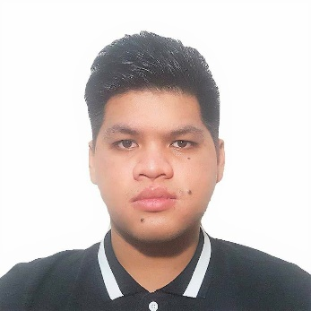

Brent
E-mail Add.: brent.379707@2freemail.com

OBJECTIVES: To further my experience and knowledge and learn new strategies and methodologies in the field of engineering construction and management, and to share my knowledge and skills while interacting with others to the growth and success of the organization.
EDUCATIONAL BACKGROUND:
COLLEGE:
- Bachelor of Science in Civil Engineering
- Holy Angel University
- Angeles, Pampanga, Philippines
- April 2015
HIGH SCHOOL:
- Guagua National Colleges Montessori
- Guagua, Pampanga, Philippines
- March 2010

ON THE JOB TRAINING:

Estimator
Provincial Engineering Office Pampanga, Philippines (PEO) (April 2014 – May 2014)
- Quantity estimates of materials

WORK EXPERIENCE:
Position: Jr. Site Engineer
Company: CMungcal Engineering (January 2016 – February 2018)
Projects: Palladium Hotel, Capitol Hills Hotel, Angeles City, Philippines
Duties and Responsibilities
- Review drawing and make estimate and program of works for purpose construction and rehabilitation project.
- Project supervisor of work phase as per specified plan and project specification.
- Monitor progress of work in accordance with the given timetable on project planning schedule.
- Attend regular construction meeting and other meetings which required by the management.
- Prepares daily/weekly progress report concerning all activities, utilized equipment, and workforce.
- Supervising, monitoring and interpreting the drawings/plans for actual implementation.
- Oversees the workmanship of workers to maximize daily accomplishment.
- Reports to the project manager regarding problems and daily issues that arises during project execution.
- Overseeing quality control and health and safety matters on site.
- Preparing estimates and shop drawing for additional works.
- Preparing of bar bending schedule for beams, columns, and slab to be used in the construction phase.

Position: Cadet Engineer
Company: E.M.Danan Construction (April 2015 - December 2015)
Project: Residential, Quezon City, Philippines

Duties and Responsibilities
- Monitors daily activity on site.
- Checking of plans, drawings for actual implementation.
- Preparing daily/weekly progress report.
- Checking materials for compliance with the specified requirements.

Skills/Interest:
- Technical knowledge of construction process
- Strong numerical and analytical skills
- High attention to detail
- Has knowledge of Quantity Take-off
- Has knowledge in AutoCAD 2D
- Has knowledge in MS Office
- Can work well both independently and as a team
Seminars/ Training Attended:
Colloquia 2015 – UPLB, Los Banos, October 4, 2014
Computer-Aided Quantity Surveying-August 21 to September 18, 2016
AFFILIATIONS:
Philippine Institute of Civil Engineers – Member, HAU Chapter, June 2014-Present

PERSONAL INFORMATION:
Nickname: Brent
Gender: Male
Age: 23
Date of Birth: October 08, 1994
Height: 5’7”
Weight: 85 kg.
Visa Status: Visit Visa

