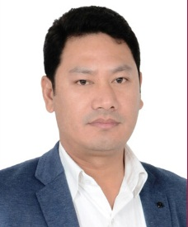
CURRICULAM VITAE
MOHAN
Email: mohan.379716@2freemail.com

CAREER OBJECTIVE
Seeking a challenging security guard related position with a dynamic and exciting organization where my retail knowledge, experience and skills will contribute towards the growth and success of the organization and as well as mutual benefits.
PERSONAL DETAILS
Date of Birth : 23/08/1979
Gender : Male
Marital Status : Married
Nationality : Nepal
Height : 5’10”
Weight : 75 kg
Health status : Healthy
Visa Status : Employment visa

PASSPORT DETAILS
Date of issue : 06 Mar 2014
Date of expiry : 05 March 2024
LANGUAGES KNOWN : English,Hindi,Arabic,Nepali
EDUCATIONAL QUALIFICATION
- Intermediate +2 passed from Shree Gauri Shankar Higher Secondary School Ramechhap,NEPAL.
WORKING EXPERIENCE
- Basic knowledge &Training in Guarding at Group 4 Falck Nepal.
- Group 4 Falck Nepal( p) Ltd a Security Guard from August 2003 till July 2005.
- Professional security services co (PSSC), Doha,Qatar as a security officer from july 2005 to till may 2009 and from june 2009 till September 2012 as a security team leader .
- Worked as a NAFT petrol pump Incharge in Saudi from sept 2014 to October 2016
- Recently working as a Security Guard at Ansar Group in Dubai march 2017 to present
DECLARATION
I hereby declare that all the information provided above is true to the best of my knowledge and I assure that I will be more sincere towards learning and delivering my utmost caliber for the growth of the organization.

