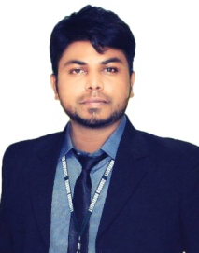
SHAKAIB
Email: shakaib.379720@2freemail.com
Dubai, UAE

CAREER OBJECTIVE:

Seeking challenging opportunities to utilize my skills for the success of the organization and collaborate with senior team to evaluate business operations efficiently and effectively. To stop at nothing to bring success and prosperity to whatever I may set my heart and mind. Not a clock watcher. Ambition and motivation are two values I truly cherish.

CAREER PROFILE/SKILLS:

- Having advanced level of experience in Advertising and Marketing of a Brand.
- Experience in conducting Marketing campaigns and trade shows to promote brand awareness among consumers.
- To produce the promotional materials for Brand Management.
- Having advanced level of experience in Print Media, Digital Media & Electronic Media.
- Team Player/Client Services/Coordination/Advertisement/Brand Management/Event Management.
PROFESSIONAL WORK EXPERIENCE:

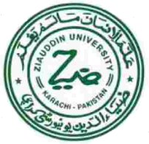
Organization: Ziauddin Group
(Leading Advertising Organization)
Tenure: March 2016– February 2018
Designation: Marketing Executive Assistant

Responsibilities:

- Overall responsibility for brand management and corporate identity.
- Coordinating marketing projects and activities as requested.
- Responsible for PR policy and strategy as instructed by the Senior Management from time to time.
- Producing additional marketing communications, such as flyers, brochures and exhibition-related projects.
- Assist in designing and developing marketing collaterals and promotional materials.
- Conduct marketing campaigns and trade shows to promote brand awareness among consumers
- Responsible for Website Management and digital marketing in all its forms.

Achievement:

- Have got honor of appreciation for Employee of the Month in October 2017.
- Manage all successful Events of the Organization in 2016 & 2017.

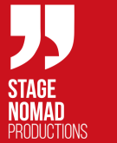
Organization: Stage Nomad Production
(Leading Production Company like RGB Production)
Tenure: July 2015 –January 2016
Designation: Digital Marketer

Responsibilities:

- Generating content for social media marketing.
- Coordinate with management about the campaigns for promotions.
- Research and develop ideas for social media content, across a variety of industries.

Achievements:

- Having successful ratings on my content of promotion on Digital Media.

Organization: Web Enthusiasts
(Leading Advertising Agency like Al Qudrah)
Tenure: December 2014 – March 2015
Designation: Promotion Executive

Responsibilities:

- Develop and maintain a solid customer base for the company.
- Sales and promotion of the company in general with existing marketing tools
Achievements:

- Working with the core team lead of that organization with courage and motivation.

ACADEMIC EDUCATION:

DEGREE/CERTIFICATION | EXAMINING BODY: | YEAR
Masters in Advertising | IQRA University Karachi | 2017
Bachelor of Commerce | University of Karachi | 2012

CERTIFICATION/ ADDITIONAL SKILLS:

- Certificate of IT (All versions, esp. MS Office, Internet, Installation)
- Diploma of Computer Operator (MS Suite, Documentation, Data Entry)
- Certificate of Ms Office (MS Word, MS Power Point, MS Excel, MS Formulae)
- Diploma of Multimedia (Adobe Creative Suite)
- Diploma of English Language (Basic Level, Intermediate Level, Advanced Level)

TRAININGS & WORKSHOPS:

Computer Operator Training – STEVTA Year - 2013
- 1 year training of Documentation & Data Entry for the enhancement of Computer Skills.

Ms Office Training – SDCK Year - 2010
- Intermediate and advance levels of Ms Word, Ms Power Point, Ms Excel

PERSONAL INFORMATION:

Date of Birth : 30 October 1991

REFERENCE:

Reference will be furnished on demand.

