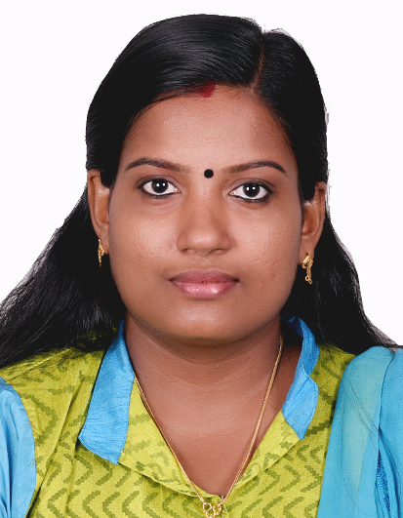

 |  |  | Revathy.
 |  |  | revathy.379773@2freemail.com
 |  |  | DUBAI, UNITED ARAB EMIRATES
ACCOUNTANT
CAREER |  | Passion, Presence and Charisma; ability to build relationships and strategic
OBJECTIVE |  | partnerships with different types of customers, ability in providing strategic
 |  | Initiatives for area, key accounts and segments.
CAREER |  | Post Graduate in MBA with more than four years of professional work
SUMMARY |  | Experience in Finance and Accounts.
EXPERIENCE  SUMMARY |  | - Performing Accounts Payable work through SAP, ERPs- Oracle and BPCS and lasvegas  - Reconciliation of daily reports  - Maintain GR database and working with vendor.  - Responsibility to resolve the issues of supplier relation team and vendor  - Try to find process improvement opportunities.  - Management Reports for process improvement on weekly/monthly basis  - Preparation of finalization of accounts.(Trading and profit and loss account and balance sheet)  - Try to find out process improvement
WORK  HISTORY |  |  | 1. Organization: EXL Service (Outsource Partners International Ltd.)  Job profile: Accountant  Tenure: October 2013–January 2015  2. Organization: Xerox business service LLC  Job profile: Senior Accountant  Tenure: April 2015 –March 2018
Graduate in MBA with more than Four years of professional work Experience in Finance and Accounts.

EDUCATION

COMPUTER SKILL

PERSONAL

PROFILE
M.B.A Major in Finance & HR
ANNA UNIVERSITY CHENNAI INDIA

Good work experience in computer Software’s like MS OFFICE ADVANCED, INTERNET, and Excel etc.

Accounting Packages like, SAP, Oracle.

Date of Birth 12-09-1990
Sex Female
Religion Hindu
Nationality Indian
Marital Status Married
Languages Known English, Malayalam, Tamil

DECLARATION I hereby certify that all the above furnished information’s are true and original
Certificates in support of the same will be presented upon request.

