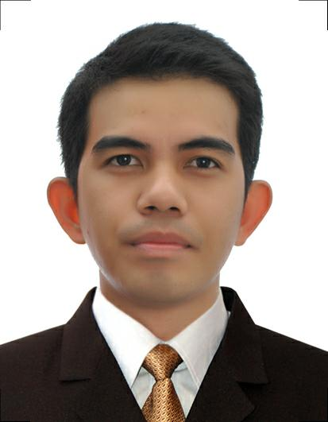
Vincent, RRT
Sharjah, United Arab Emirates
vincent.379780@2freemail.com

Date of Birth: October 14, 1988
Civil Status: Single
Place of Birth: Cagayan de Oro City
Nationality: Filipino
Profession: Radiologic Technologist PRC # 10231
Visa Status: Tourist Visa

I. Objective:
Position in reputed medical institution where my acquired experience/skills will provide radiographic diagnostics services to further promote department concepts and development of the institution.

II. Experience:

Maria Reyna Xavier University Hospital(August 2014- to February 7, 2018)
-Handled Ct-scan (GE Brightspeed 16slices) and can perform plain and with contrast procedures (Whole Abdomen, Urogram, Angiogram, Brain, Neck, Chest and Extremities).
-Computed and Conventional Radiography (Elan Vita iCR)
-Handled C-Arm (GE Brivio)
ButuanDoctors’sHospital( September 2012- January 2014)
-Handled Ct-scan (Phillips MX16) and can perform plain and with contrast procedures (Whole Abdomen, Urogram, Angiogram, Brain, Neck, Chest and Extremities).
-Computed and Conventional Radiography (Carestream Classic CR).
-Handled C-Arm (Phillips Endura).

III. Educational Attainment:

College: Bachelor of Science in Radiologic Technology – Batch 2012
Liceo de Cagayan University
Rodolfo N. Pelaez Blvd., Carmen, Cagayan de Oro City

High School: Corpus Christi School
Graduated – Batch 2005
Macasandig, Cagayan de Oro City

Elementary: Corpus Christi School
Graduated – Batch 2001
Macasandig, Cagayan de Oro City

Licensure Examination:
Licensure Examination Radiologic Technology – June 2012
-Given by the Professional Regulation Commission (PRC) – PASSED

IV. Skills:

- Knowledge of radiographic procedure, equipment and radiation safety (patient and operator).
- Ability to handle effectively with the stress of multiple priorities and patient anxieties.
- Excellent interpersonal skills in dealing with patients, public and co-workers.
- Work with less supervision
- Proficient with Microsoft Word, Excel and Power point.

V. Seminars/Trainings Attended:

Basic Life Support Training
Maria Reyna Xavier University Hospital
Hayes St. CDOC
August, 2015

MRI Training
Metropolitan Hospital
Bambang St., Metro Manila
February 2013

Pre- Employment and Job search management
AVR 1, Liceo de Cagayan University
Rodolfo Pelaez Blvd, Carmen, CDOC
September, 2010

Career Planning and Management
AVR 2, Liceo de Cagayan University
Rodolfo Pelaez Blvd, Carmen, CDOC
September, 2010

