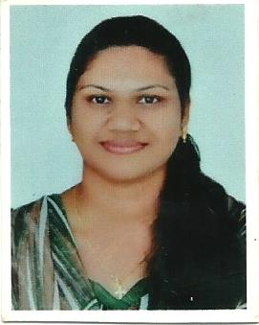
SINI
EMAIL ID: sini.379792@2freemail.com

PERSONAL SUMMARY
An astute nursing professional with total almost 12+ years of extensive experience in . A highly competent and enthusiastic career with an outgoing personality, great communication skills and a passion for caring for others. Multi-skilled and self motivated with a dedication for providing personal and physical care on a one-to-one basis. Having a proven ability to meet the personal care needs of service users in a way that respects the dignity of the individual and promotes their independence. Using initiative to develop effective solutions to problems with an active and dynamic approach to work and getting things done efficiently & unsupervised.
Currently looking for a suitable career position with a ambitious employer.
PROFESSIONAL EXPERIENCE
Dr.Abdul Latheef’s Clinic ,Deira ,U A E
Assistant Nurse& Dental Nurse- From 03/12/2005 - Present
Duties.
- Educates patients; responds to consultations made by physicians.
- Performs patient histories and physical examinations under physician supervision; evaluates results and monitors treatment plans; maintains medical records.
- Providing advice and emotional support to patients.
- Oversees patient schedules, appointments, and procedures; attends and assists during surgical procedures.
- Updating a clients medical records and other paperwork.
- Assesses patient’s physical needs including pain assessment.
- Assesses patient’s psychosocial and behavioral health needs.
- Assesses patient’s and families’ learning needs.
- Provides patients and families with appropriate education.
- Advocates for the patient.
- Administers prescribed medications and treatments.
- Performs other duties as assigned.
PREVIOUS EMPLOYERS
GuruNanak Hospital,Mumbai,India
Staff Nurse From 20/02/2004 to 17/10/2005
Sevanam Hospital,Kerala,India
Staff nurse from 01/01/2003 to 31/01/2004
Moulana Hospital,Kerala,India
Staff Nurse from 16/09/2000 to 30/09/2003

KEY SKILLS AND COMPETENCIES
- Knowledge of medical procedures, terminology, and equipment.
- Interpersonal/human relation skills.
- Patient assessment skills.
- Verbal/written communication skills.
- Ability to apply good clinical judgment.
- Ability to plan work, establish priorities, and remain flexible.
- Ability to maintain confidentiality
- Ability to instruct/teach
EDUCATION AND CERTIFICATIONS
1997-2000 BHARATHIAR UNIVERSITY
Diploma in GENERAL NURSING
DHA LICENCE - DHA/LS/2992011/241702
BLS CERTIFICATION COURSE NUMBER: BLS-04/11/2017
PERSONAL INFORMATION
Nationality: INDIAN
Date of Birth: 28/05/1979 Gender: FEMALE

TECHNICAL ABILITY

- Microsoft Office proficient; Word, Excel, PowerPoint, Outlook, Internet research expertise.

References available upon request

