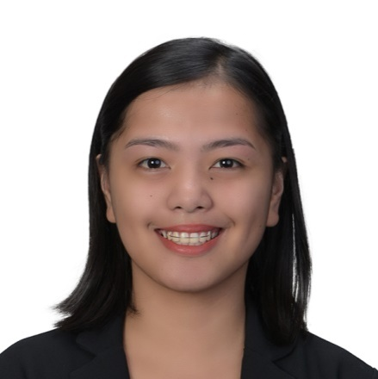
JOBELLE
EMAIL ADDRESS: jobelle.379816@2freemail.com

MEDICAL TECHNOLOGIST
(DHA Eligible, ASCP^{i} Holder, AHA-BLS Certified,
3 year-experience)

PROFESSIONAL WORK EXPERIENCE

COMPANY NAME | INCLUSIVE DATES OF EMPLOYMENT | POSITION
UB Clinical Laboratory | August 2016- May 2017 | Medical Technologist-C.I.
La Trinidad Diagnostic MPC | December 2014- June 2016 | Medical Technologist
Ilocos Training and Regional Medical Center (ITRMC) | November 2013- May 2014 | Medical Technologist Intern II
Saint Louis University  Clinical Laboratories | May 2013- November 2013 | Medical Technologist Intern I

PROFESSIONAL LICENSE

LICENSE | GOVERNING BODY | DATE
Dubai Health Authority  (with Eligibility Letter) | Dubai Health Authority | February 27, 2018
Certified International Medical Laboratory Scientist, MLS(ASCPi)  License No. 25581168 | American Society for Clinical Pathology (ASCP), Chicago, Illinois | July 29, 2016
Registered Medical Technologist (Reg. No. 0068082) | Professional Regulation Commission, Philippines | September 13-14, 2014

FORMAL EDUCATION

LEVELS | SCHOOL/UNIVERSITY | INCLUSIVE YEARS OF EDUCATION | DEGREE EARNED | AWARD/S RECEIVED
Primary | Baloy Elementary School, Philippines | 2000-2006 | Graduate | Valedictorian
Secondary | Saint Pius X Institute, Philippines | 2006-2010 | Graduate | With Honor
Tertiary | Saint Louis University (SLU), Philippines | 2010-2014 | Bachelor in Medical Laboratory Science
Graduate School | Saint Louis University, Philippines | 2016 | Master of Science in Medical Technology (12units)

ACTIVE MEMBERSHIP IN ACCREDITED PROFESSIONAL ORGANIZATIONS

NAME OF ORGANIZATION | INCLUSIVE DATES OF MEMBERSHIP/VALIDITY | POSITION
American Society for Clinical Pathology (ASCP) | 2016-Present | International Medical Laboratory Scientist (Member)

PROFESSIONAL DEVELOPMENT ENGAGEMENTS

TITLE OF TRAININGS/SEMINARS | DATE | INSTITUTION/VENUE
LabQ: Plasma or Serum? Issues with Processing Plasma and Serum Specimens at Ancillary Phlebotomy Locations | March 31, 2018 | CMLE-ASCP
LabQ: Glomerular Filtration Rate: Creatinine and Cystatin C | February 25, 2018 | CMLE-ASCP
Electrolytes | February 22, 2018 | API/ASCP Educational Commentaries
CMLE-Understanding Laboratory Test Limitations Can Improve Accuracy in Diagnosing Heparin-Induced Thrombocytopenia Diagnosis | January 31, 2018 | CMLE-ASCP
BLS for Health Care Provider Course | November 16, 2017 | Global CE Provider of America
2016 NEQAS Orientation and Workshop on RIQAS by RANDOX | August 4, 2016 | Randox  YMCA, Baguio City
“Molecular Pathology Made Simple” Postgraduate Course | April 25-26, 2016 | St. Luke’s Medical Center-Institute of Pathology
1st Continuing Professional Development Lecture-Seminar | February 21, 2016 | PAMET Baguio-CAR Chapter
2nd CPD Scientific-Lecture Seminar (Molecular Cytogenetics, Forensic Science, Emerging Infections and Professional Ethics) | April 19, 2015 | PAMET Baguio-CAR Chapter
Basic Electrocardiography & Electrical Treatments | July 5, 2014 | iNurses
PERSONAL INFORMATION

Date of Birth: | May 25, 1994
Nationality: | Filipino
Status: | Single
Visa Status: | Visit Visa
__________________________________________________________________________________
I hereby certify that the above information is true and correct to the best of my knowledge and belief.
JOBELLE

