Biju
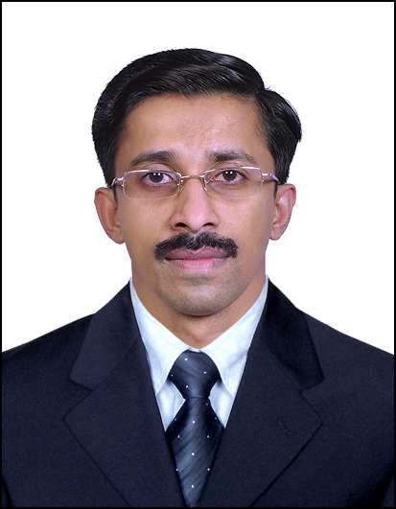

Email : biju.379829@2freemail.com

SUMMARY
- ExperiencedProcurement Professional in construction industry with skills&ability in Material / Inventory management.
- An effective communicator with excellent relationship management skills and Strong analytical, problem solving and organizational abilities, ready to work hard and willing to learn.
- Self-starter with ability to overcome obstacle and rebound from setbacks.
- Ability to adjust schedules appropriately to manage multiple and changing priorities, as well as emergencies.
- Able to work independently and also to work in a collaborative effort with other team members as necessary to quickly and effectively resolve technical issues and provide the necessary result.
- Strong organizational skills and have the ability to communicate issues and status in a targeted manner.
- Able to articulate technical and business concepts.

Employment Details:-

Sr. Purchase Officer - Working since November 2005 (+11 years)
Al Hamra Construction Co. L.L.C. is a sister concern of RAK Ceramics, Handling projects of yearly 200 Million.
Responsibilities:-
- Responsible for all the needs of the company including managing the purchasing and controlling inventory.
- Checking the requirement of stores and construction sites and take measures to avoid duplicate purchase and over stocking.
- Sending enquiries to prospective customers who can provide the best quality materials at lesser price.
- Finalizing the purchase with the consent of end-user.
- Sourced and negotiated pricing for 600 items with an annual purchased value of $20 million including establishing blanket purchase agreements and bulk commodity pricing agreements.
- Interacted with all departments in the Construction Division, the G.M of the Construction Division, production Managers, site Engineers, accounts, stores etc.
- Full Cooperation with clients satisfying their requirements to the fullest.

Store-In-Charge Since November 2002- October 2005 (3 years)
Rak Ceramics, Ras Al Khaimah, UAE. ISO9001 Company. Export to 135 countries. Responsibilities:-
- Checking the quantity as per the concern.
- Preparing documents for the received materials and making the records.
- Handling all types of imported and local materials.
- Full Cooperation with clients satisfying their requirements to the fullest.
- Coordinating with Site Staff & Coworkers.
- Strong organizational skills and have the ability to communicate issues and status in a targeted manner.

Educational Qualifications:-

- Masters – EMBAinSupplyChainManagement (Pursuing) IndianInstituteofBusinessManagement& Studies
- Graduation - B.Com, Mahatma Gandhi University, Kerala, India
- Diploma in Computer Application Micro tech computers, Kerala, India.
- Certificate awarded by CT&T, which is incorporated to TEXAS U.S.A

Computer Awareness
Operating system : Windows
Document processing : Microsoft Word (Updated Version)
Spread Sheet : Microsoft Excel (Updated Version)
Presentation : Microsoft PowerPoint (Updated Version)
Languages :Turbo C, Visual Basic
Accounting Software : Tally 7.2
Programming Software : Oracle

Personnel Information’s

Sex : Male

Nationality : Indian

Date of Birth : 09 July 1977.

Languages Known : English,Arabic, Hindi, MalayalamandTamil

I, hereby declare that the above mentioned details are true to my knowledge and are confident that I’m the only candidate uniquely qualified to fill this vital position in your company.

