FAZIL CIVIL SITE ENGINEER

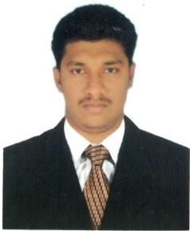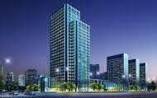

E-mail fazil.379844@2freemail.com

Personal Data D.O.B : 22.04.1995
Sex : Male Nationality : Indian Status : Single Visa Status : Visit Visit Expire: 3 . 7 . 2 0 1 8

Languages Known
- Tamil
- English

SUMMARY
Seeking a responsible, challenging and permanent position to employ my education and experience with reputed and progressive organization in the field of leading construction & contracting companies so as to be recognized as a leading professional.

STRENGTHS
- Problem Solving Skills.
- Good Communication Skills.
- Leadership Qualities.
- Good Observation and Manipulation.
- Hard and Efficient Worker.
- Fast Learner.
- To know more about Construction Field.

TECHNICAL PROFILE
Technical Qualification : Civil Engineer

Technical Skills : Project Management, Creativity,
Critical Thinking.

COMPUTER SKILLS
Design Oriented Packages : Auto-Cadd,
2D, 3D & Revit 2015.

Application Packages : MS-Office
(Word,Excel,PowerPoint)

EDUCATION PROFILE
- B.E., Civil Engineering in Anna University, Chennai (Batch2012-16) FIRST CLASS

- HSC in ARR Matriculation Higher Secondary School, Kumbakonam(2011-12)

- SSLC in ARR Matriculation School, Melacauvery (2009-10)

CAREER DETAILS
Duration : April 2016 - October 2017 Company : PG Construction, Kumbakonam Position : Site Engineer
Project : Four Storey Commercial Building

JOB RESPONSIBILITIES
  - Quantity Surveying
  - Preparing payment Certificates for Sub-Contractors
  - Supervision on Site work
  - Studying the main contract & the Contracts of Sub-Contractors
  - Preparing daily & Weekly Report to Project Manager

Duration : Jan 2016 - March 2016 (Part time) Company : Mass Construction-Kumbakonam Position : Site Engineer

JOB RESPONSIBILITIES
  - Preparing Payment certificates for Sub-Contractors
  - Supervision on site work
  - Studying the main contract & the Contracts of Sub-Contractors
  - Preparing Daily & Weekly Report to Project Manager

ACADEMY PROJECT
- Project Title : Experimental Study on Bricks
- Duration : April 2016
- Grade : Excellent

MAJOR STRENGTHS
- Honest
- Hard Working
- Ability to work as Team
- Be Friendly

DECLARATION
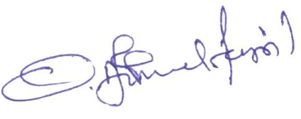
I hereby declare that all the information furnished above is correct & true to the best of my knowledge and I bear the responsibility for the correctness of the above-mentioned particulars.
Place: Date:
( FAZIL)

