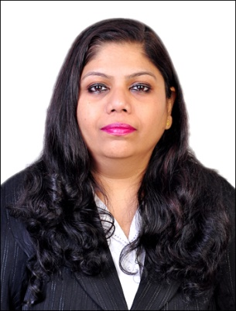
Curriculum Vitae

NAME : Hemangini

DATE OF BIRTH : June 22nd1974

NATIONALITY : Indian

MARITAL STATUS : Married

Email : hemangini.379849@2freemail.com

Educational Qualification : Bachelor of Arts.(History/Sociology)
(II Class – MumbaiUniversity)
Master of.Arts.(History)
(II Class – Mumbai University)
Bachelor of Library and Information
Science
(II Class –Mumbai University)
Bachelor ofEducation
(Grade B from Mumbai University)

Additional Qualification : Diploma in Telephone
& TelexOperation

Certificate course in computers,SwiftJyothi from NIIT

Cambridge International certificate-
Professional development course- Secondary 1

Languages Known : English,Hindi,Marathi&Gujrati

Professional Synopsis
- Worked as atelephone operator cum receptionist in Sarla Nursing Home, Santacruz, west from September 1990 to August 1991.

- Taught in Several Coaching Classes & have conducted Private Tuitions for School as well as college students from September 1991 to September 2014.

- Worked as Assistant Teacher at L.S.Raheja College – Mumbai, injunior section for History from November 1999 to April 2000.

- Worked as a teacher of Social Studies at Chate Coaching Classes Pvt. Ltd,Borivali East branch from November 2000 to April 2001.

- Library internship done at Janmabhoomi Groupof Newspapers,Library & Ruia College -Library.

- Have been Conducting Private Tuitions from residence& own establishmentfor school students from Class I - Class x& Bachelor of Arts students in daily 3 Batches for totally 30 students since June 2001
to September 2014.

- Have taught in Rustomjee Cambridge International School,Mumbai since November,2014 to May 2016, as a co Class teacher of standard VI & teaching Social Studies to VI &VII Standard students.

- Currently working with Dr Pillai Global Academy,Mumbai as a Teacher Librarian, since June 2016 as to date ,where I handle the library and teach the subject History. I am also a subject coordinator for the same.

Core Competencies
- Very sound teaching skills withtwenty seven years profound teachingexperience, of which more than three years I have been working with schools having IGCSE and IB curriculum.

- Have brought about marked improvement in proficiency of School students & Arts students at all levels by modern teaching techniques.

- Adopting innovative methodology of conducting weeklytestsfor all students in self-owned coaching classes by the name “Sai Study Centre” , whereby the knowledge grasping capabilities ofall students are judged & a special programme for the weak & the excellent students are conducted for enhanced achievement.

- Sound Knowledgeof computers,good in web research &analysis, Ms Office ,Excel &PowerPoint.

- Very sound Knowledge of modern English teaching techniques& excellent spoken English personally.

- A vast experience in teaching students from SSC, CBSE, ICSE& IGCSE education boards.

- Handled grade 6 and 7Secondary School students effectively as co class teacher & as a reader for formative assessment for slow learners.

- Have taught history to the primary grades as well.

- Have made worksheets as per the curriculum for primary students n check point students.

- Conducting reverberations for secondary students for Social Studies
Projects where they are given marks for the same.

Have been conducting History Geography Day each year for the students, where students make models and dress up and give presentations on the topics from their syllabus.

Havehelped students in conducting activities for other subjects like Maths, Science,French,Spanish, Language day etc.

Been working as a Teacher Librarian for an IB school,where I handle the library as well as teach History, I am a subject coordinator – teachersreport to me for coordination.

As a Librarian I weeded out all the unnecessary books in the library and held an exhibition cum sale for the students and parents. This benefited both the students and the Management alike.

Everyyear during a Literature Fest I set up a mini Library for the benefit the students and parents where non regular resources are put on display.

Under my supervision the book in the library have grown to nine thousand in numbers.

