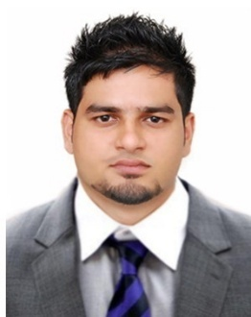
KHADER
Email: khader.379873@2freemail.com

Career objectives
To pursue a career in an organization that offers continues professional growth along with the professional satisfaction by exposing to new challenges. So that I can, but my analytical and conceptual skills to test while being resourceful to organization.

Functional skills
- Have more than 5 years of experience in sales & marketing in India & UAE with reputed organizations.
- Hard worker, Proactive, have good ability to contribute in teamwork and willing to work under stress.
- Good Communication skills and establishing effective relationships with clients.
- Problem solver, decision maker, Creative and result oriented.
- An independent and self-motivated professional & able to grow positive relationship with clients and colleagues at all organizational levels.
- Works well in both team environment and individual assignment.
- Successful in meeting new technical challenges and finding solutions to meet the needs of the clients.
- Energetic and enthusiastic with refined manners.
- Self-motivated and ambitious with strong desire to succeed.
- Good inter-personnel skills with excellent verbal and written communication skills.
- Quick learner, good analytical and conceptual skills.
- Self-confidence.

EDUCATIONAL QUALIFICATION
- BBM (Marketing) - Bachelor of Business Management
Mangalore University, 2008-2011
- Diploma in IATA/UFTAA FOUNDATION & EBT course from montreal Canada Through KUONI ACADEMY of travel & tourism, mangalore-2011
- Attended various courses in Sales skills, Computer skills, advanced skills, Communication skills, Negotiation skills and product Knowledge.

Computer Skills ; Microsoft Office.

Languages Known ; English, Hindi and other south Indian.

PERSONAL EXPERIENCE

From Nov 2017 till present
Name of the Organization; IMPERIAL AC SPARE PARTS TRADING LLC
Position Held ; Sales Manager

From Jan 2017 to Aug 2017
Name of the Organization; DANA GROUPS
Position Held ; Sales Executive

From Jan 2015 to Dec 2016
Name of the Organization; PRIME AIRCONDITIONING INDUSTRIES LLC
Position Held ; Sales Executive

From Nov 2013 to Dec 2014
Name of the Organization; IMPERIAL GENERAL TRADING FZCO
Position Held ; Sales Assistant

From Sep 2011 to Sep 2013
Name of the Organization; INDUSIND BANK LTD
Position Held ; RO (relationship officer - market)

Personal Details
Date of Birth ; 22/01/1990
Marital Status ; Single
Nationality ; Indian
Visa Status ; Employment/transferrable
Driving licence ; UAE

Declaration
I hereby declare the information given above is true as per my knowledge and belief.

