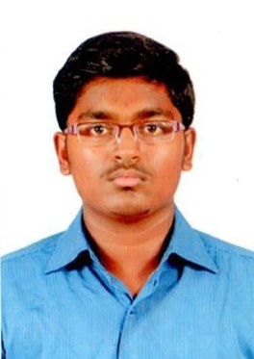SHIEK
shiek.379885@2freemail.com

Career Objective
A position in the Aviation Industry where my past and varied experience would be fully utilized and to make a significant contribution to the success of my Organization
Professional Experience
Organization | Designation | Duration Of Service
VORTEX ENGG PVT LTD | CUSTOMER SUPPORT EXECUTIVE | 1YEAR 2 MONTHS

Aviation Qualifications
Course | Institution | Year Of Passing
Advanced Diploma In Airport & Airline Management | PTC Aviation Academy, Chennai | 2017
Advanced Diploma In International Air Travel Management | PTC Aviation Academy, Chennai | 2017
Advanced Diploma in Air Cargo Management | PTC Aviation Academy, Chennai | 2017

Academic Qualifications
Course | Institution | Year Of Passing
B.C.A. | MOHAMEED SATHAK COLLEGE OF ARTS & SCIENCE. | 2015
12th Std | A.K.T. Hr.Sec School | 2012
10th Std | A.K.T. Hr.Sec School | 2010

Area of Interest
- Ground Staff
- Security Staff
- Airline Cargo Staff
- Customer Support executive
- Ticketing Agent
- Managing supervisor

Skills
- Good Communication Skills
- Good Knowledge on Computer Operations
- Ability to think critically and analyze situations
- Leadership Qualities and a good team player
- Adaptable to different work conditions
- Interpersonal Skills

Personal Information

Name : SHIEK
Gender : Male
Date Of Birth : 29.03.1995
Nationality : Indian
Marital Status : Single
Languages Known : English, Tamil, Hindi, Urdu

Looking forward to join your Organization at the earliest and provide the highest standards of service in the Industry.

