Spyridon
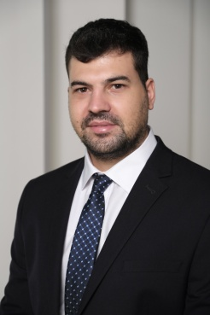
Email: spyridon.379890@2freemail.com
Nationality: Greek
Military Service: Fulfilled

OBJECTIVE
A leading professional role in a multinational company, where my experience, skills and goals will create a motivated workforce, to accomplish the organizational goals.

PROFESSIONAL BACKGROUND

December 2016 to March 2018
Revenue Analyst at Revenue Management department of Avis Budget Group, Athens, Greece
Responsibilities and skills:

- Managing optimization process, focusing on distribution, pricing, segment management and demand management.
- Conduct pricing forecast.
- Recommend pricing strategy and pricing tactics.
- Supporting the development and maintenance revenue management process and tools.
- Delivering high quality quantitative analysis to support own recommendations.
- Communication and relationships with key stakeholders in other departments.
- Support communication and reporting for regional board.

December 2015 to December 2016
Customer Care Executive at Avis Budget Group, Athens, Greece
Responsibilities and skills:

- Answer incoming calls for car rentals and leasing.
- Refer unresolved customer grievances or special requests to designated departments for further investigation.
- Managing emails regarding car rentals and leasing with companies partners and agencies.
- Support sales organization in building private prices and promotions based on specific market needs especially in companies and travel agencies.
- Provide information according to company’s policy and procedures.

June 2013 to October 2013
Internship at KAITI TSATSARI accounting office, Athens, Greece
Responsibilities and skills:

- Preparing asset, liability, and capital account entries by compiling and analyzing account information.
- Documenting financial transactions by entering account information.
- Secure financial information by completing data base backups.

EDUCATION

2009-2014 University of Piraeus, Athens, Greece
Bachelor Degree in Financial and Banking Management
- 2003-2009 Moschato High School , Athens, Greece
High School Diploma

LANGUAGES

Fluent in English, German, Greek

SKILLS

Microsoft Office Core Diploma (ECDL), SAP, excellent oral and written communication skills

SEMINARS-TRAININGS
- Research during my studies in University of Piraeus (1/2/2013 – 1/7/2013) about the influence of green development on a company’s sustainability.
- Seminar: Contemporary Customer service techniques and ways to cope with demanding Customers.
- Seminar: The implementation of mathematics in economy and analysis of financial products.

HOBBIES

Cinema, Traveling, Sports

References available upon request.
‍

