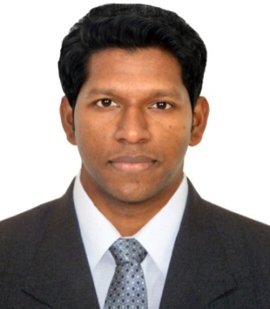
Arun
D O B : 30-07-1990
Email: arun.379903@2freemail.com
Nationality: Indian
Visa Status: Visit

Objective
Diligent Civil Engineer having 5 years’ experience in building construction (3 years in GCC+ 2 Years inIndia).Autonomous worker committed to providing high-quality services, ability to work independently and as team member. Proficient in AutoCAD,3ds Max andMS Office and in possession of a Bachelor’s in Civil Engineering, moving forward to explore multi tasking and planning skills

Education
2007 – 2011 Calicut UniversityKerala
Civil Engineering
Bachelor of Technology (B.tech)

Other Certificate
3ds-max and Interior Designing.

Work Experience
Aug2016 –June 2017 TubalMaintanance&Contracting Company Riyadh, Saudi Arabia
CivilEngineer
Feb 2014 –May 2016 Salutech Contracting Riyadh, Saudi Arabia
Civil Engineer/ Planning Engineer
The company is active inthe constructionof buildings,workshopsand Curtain wall, I am responsible for
- Make Proper Bids after feasible studies,calculation of materials cost, the costforworkmanship,indirect cost,and overhead cost
- Negotiation with material suppliers and make work more profitable
- Scheduling the project works and monitoring
- Preparation of contract baseline schedule and revised schedule in coordination with project manager
- Responsible for all shop drawing,materials submission and take approval from the client
- Maintaining the project planning records
- Quantity take-off and monthly invoice preparation
- Conduct regular inspection and assess the work done by all the subcontractors
- Forecast problems as early as possible
- Records the daily progress and prepare daily,weekly,monthlyreport updates
- Working closely with all the levels of the management,engineers and field operation staffs
- Ensure that the project is executed by the plan
- Controlling resources to attain the organization goals,debugging problems and finding the way to overcome the critical situations in the projects
- Coordinating the handing over of the completed works to client and completion of the necessary rectification works
Dec 2011 – Dec 2013AAY KAY Constructions, Kerala
Site Engineer
The company was active in railway construction works, I am responsible for
- Establish,report and follow up all nonconformance activities
- Conduct daily briefing with site team leaders to follow-up and report on the work progress in order to anticipate any possible delays with regards to planned tasks
- Team leader in execution of works
- Preparation of drawings as per actual site condition and make approval from the client
- Preparation of Barbending schedules and Quantity Surveying
- Surveying and leveling of the proposed project site
- Supervision of works, and managing resources
- Ensure the availability of materials in site store
- Material purchase orders
- Quantity take-off and invoice preparations for subcontractors
- Submission of Daily, weekly reports of development of work to Project Engineer

IT skill
AutoCADExcellent
Ms office (word,excel,powerpoint) Advance
MS Project intermediate

Languages
English Advanced (Read, Write, Speak)
Hindi Advanced (Read, Write, Speak)
Arabic Beginner (speak)

