Career Objective
To be a part of an organization with an environment to enhance my career, an opportunity to use my knowledge and contribute to the success of the organization, and at the same time improve my skill.
Education
- SSLC from Sa adiya English Medium Residential Senior Secondary School, Deli, Kasaragod in 2011 with 61%
- HSC from Sa adiya English Medium Residential Senior Secondary School, Deli, Kasaragod in 2009, with 66%
- B.Pharm at Srinivas College of Pharmacy, Mangalore (affiliated to RGUHS, Bangalore) from 2011-2015 with 73%
Capabilities
- Self motivating skill
- Good team work ability
- Quick learner
- Able to pick up required skills and meet deadlines
Languages known
- Malayalam, English, Hindi, Kanada (speak)
Activities and Achievements
- Attended a National Seminar on Optimization techniques and research methodology by RGUHS, Bangalore
- Won second place in poster presentation in a national conference on ‘Herbal Drug Research Opportunities and Challenges’ by RGUHS, bangalore.
Hobbies
- Football, Bike riding, Blogging
Declaration
I hereby declare that the information provided is true.
Place
date: Signature
Abdul
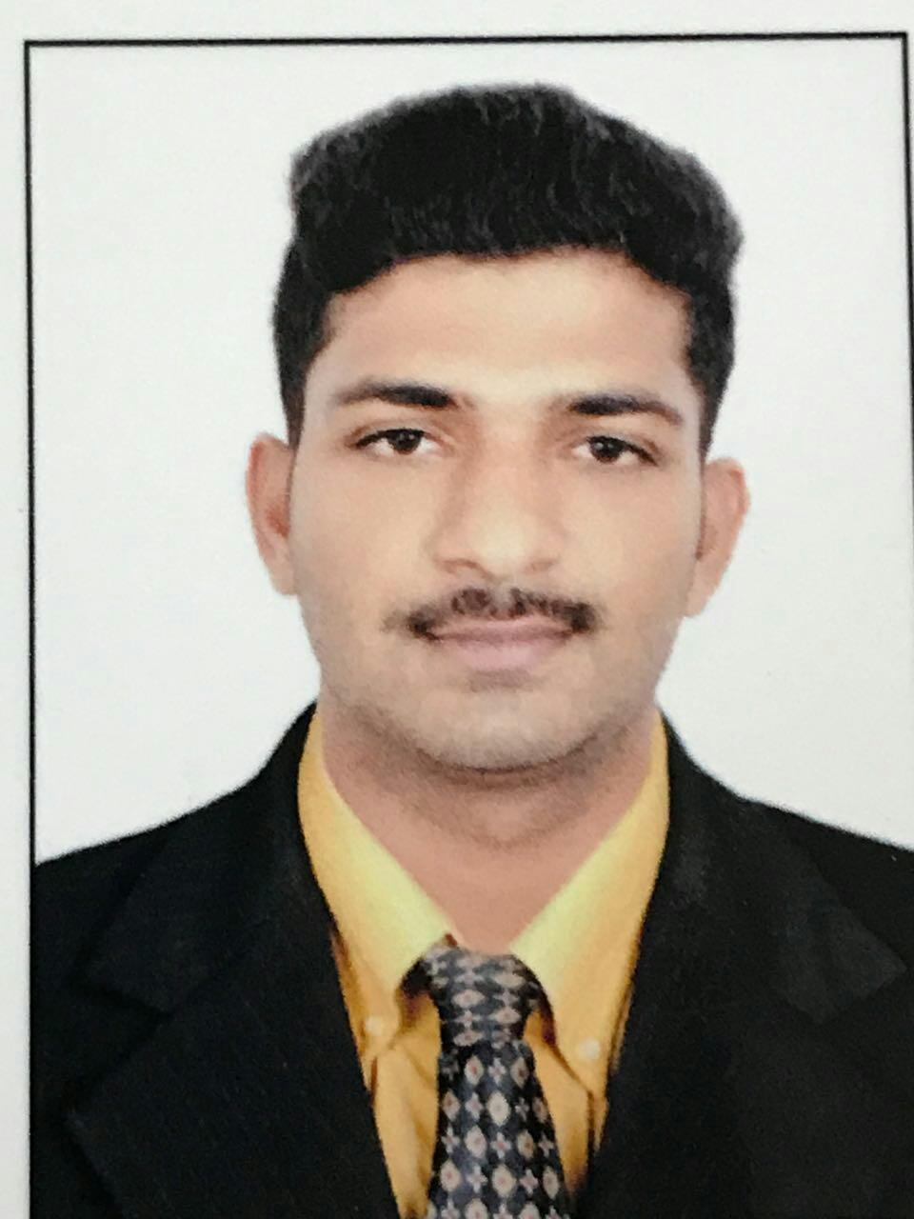

- Abdul.379905@2freemail.com
- DOB: 28-04-1993
- Gender:Male

Career Experience
- 1 year experience in Nanma medical as pharmacist in charge from 01-11-2015 to 25-11-2016.
- 1 year in Ganesh medical pumpwell as pharmacist incharge from 01-12-2016 to 15-12-2017
- Cleared DHA exam.

