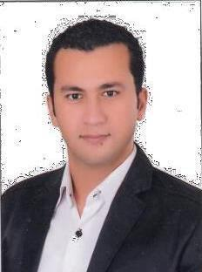
MAHMOUD

email :- mahmoud.379908@2freemail.com

Accomplishments

- Qad (qualified accountant diploma) - (EIAC)

- ICDL

- Auditing accounting - (AAIA)

- Financial accounting - (AAIA)

- Commercial excel

- English conversation

- Restriction and deportation And preparation of financial statements(Egyptian Society of Certified Public Accountants )

- QUICKBOOK

Experience

Chef accountant July 2016 to April 2018

Alnujabaa building contracting . - Dubai

Working with accounts payable , receivables , bank, and petty cash accounts.
Knowledge of weekly monthly payroll, purchase and sales tax invoices.
Checking purchase invoices to delivery notes
Auditing for stores accounts.
Auditing for fixed assets.
Handling incoming cash and posting it into the relevant bank accounts
Control the documents issued and received to the accounting department,
- and verify their authenticity and contain the necessary signatures .

Participate in the periodic and annual inventory of materials and fixed assets Preparation of salary scales and wages for employees and ensure the correct preparation of This tables
Analysis of expenses.
provides all required documents and documents on time.
Submission of correct document to the Ministry of Labor for visa applications.

Manage all types of applications and paperworkincluding Resident and Employee Visa, Labour and Immigration Cards, Labour Quota applications, Investor Visas, Offshore; Security Passes (CICPA), Emirates ID Cards, Company and Branch formation, Annual License renewals and updates.

Arrange medical tests, passports, memos, promotional draws and fine resolution.

General accountant April 2016 to July 2016.

Omega shipping EG - Alexandria – Egypt .

Senior accountant April 2014 to April 2016

Marsillia group - Alexandria - Egypt .

Education and training

- Diploma at accounting & auditing

Alexandria university

Graduation :- 2014
Grand :- excellent

- Bachelor of accounting

Alexandria university
Graduation :- 2010
Grand :- good

Personal information

Date of birth:-1/7/1989
Nationality: - Egyptian
Marital status: - single

Skills

- Team work spirit and co-operation

- Hard worker under stress

- Good communication

DRIVING LICENSE AT DUBAI :- UNDER PROCESS

Languages

- ENGLISH: - GOOD COMMAND READING AND SPEAKING

- ARABIC:- MOTHER LANGUGE

