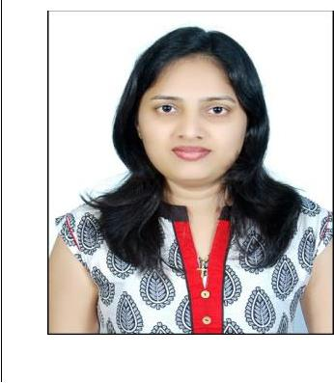

RENITA

CAREER OBJECTIVE:

Seeking a challenging career where I can utilize my abilities and skills towards growth and development of organization and make a strong contribution to the organizational goals through continued development of professional skills.

RENITA
Email Id: |  |  |  | EDUCATION QUALIFICATION:
Renita.379909@2freemail.com
 |  |  |  | 2011 – Mangalore University, Sri Mahaveera College, Moodbidri
 |  |  |  | PRE-UNIVERSITY COMMERCE
 |  |  |  | 2008 – Pre-University Muniyal
 |  |  |  | DIPLOMA IN INFORMATION TECHNOLOGY (D.I.T.)
 |  |  |  | Basic of IT, MS Windows, MS Word, MS Power Point,
Visa Status : Husband Visa |  |  |  | MS Access, 9.0 VAT Enabled, Internet, HTML and
 |  |  |  | Multimedia

Skills:

- Accounting
- Report Creation
- Sales
- Marketing
- Customer Service
- Secretarial/Reception

- MS Office Applications (Word, Excel, Power Point)

- Accounting Applications (Excel, Tally)

- Good communication skill

Personal Data:

D.O.B : 1/2/1990

Gender : Female

Marital Status : Married

Religion : Roman Catholic

Nationality : Indian

EMPLOYMENT RECORD:

- Receptionist And Assistant Accountant at Mohtisham Complex – 2 years (May 2014 to June 2016)

- Marketing Executive for Real Estate – 6 months(Sep 20113 May 2014)

- Sales Executive at Honda Matrix – 2 years(June 2011 to July 2013)

JOB DESCRIPTION:

- Prepare Monthly Reports

- Provide Weekly Progress Report on pending works

- Update all Reports in the system

- Attend meeting with HR, Manager and Director and provide report on pending works

- Coordinate with HR to give new ideas, suggestion to improve work

- Submit Daily Report to HR
- Complete daily paper works
- Daily activities like Attending calls

- Maintains security by following procedures

- Monitoring logbook, Issuing visitor badges

- Sales and Marketing

- Interact with customers while selling vehicles

Languages Known:

To Speak : English, Hindi, Kannada, Konkani

To Read : English, Hindi, Kannada, Konkani

To Write : English, Hindi, Kannada, Konkani

Extra Initiative:

- Cultural activities like dancing, singing

- Participated in NCC, Bharat Scouts and Guides.

DECLARATION:

STRENGTHS:

- 100% committed and hardworking to the job assigned.

- A positive attitude and total belief in my capabilities.

- Good listening ability and patience.

- Efficient in leading a team with the capacity of coordination.

- Zeal to learn new things.

- To lead from the front and always open to ideas

- Self-Disciplined

I hereby declare that all the information presented above is true to the best of my knowledge.

Place: Abu Dhabi | Your Sincerely
Date : | (RENITA)

