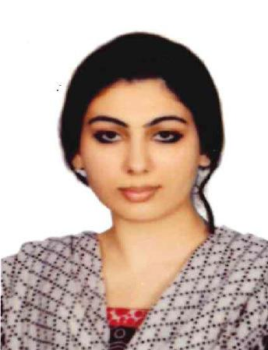

Dr. Sana

DOB: 5TH NOVEMBER 1987

C
Sana.379915@2freemail.com
AL AIN, UNITED ARAB EMIRATES

VISA STATUS: SPOUSE RESIDENCE

GENERAL PRACTIONER- HAAD CLEARED accomplished general practitioner with 4 years of experience in the medical field. Skilled in diagnosing and treating a variety of human diseases and injuries. In-depth Understanding of drug properties and interactions, procedural techniques, and preventative health-care methods. Ability to provide psychological diagnosis, treatment, and rehabilitation for patients with mental and physical dysfunctions. Extraordinary decision-making skills and critical thinking capabilities.

AREAS OF EXPERTISE

Critical thinking Taking Medical History

Superior communication skills
Physical examinations

Patient counseling
Liaising with other
professionals

healthcare

PROFESSIONAL EXPERIENCE

MEDICAL OFFICER, KASHMIR HOSPITAL
01-DEC-2013 – 24-DEC-2017

Administer treatment, medication, therapy, vaccinations, and other medical care to treat patient diseases, injuries, and illnesses.

Prescribe medication or specialized care to meet specific patient needs.

Monitor the progress and current condition of patients to determine whether current treatments are working or if modifications are needed.

Collect patient information (including examination results, medical history, and other reports). Record information in electronic filing systems.

Explain test results and recommended procedures to patients.

Answer patient questions and use active listening skills to understand and address concerns.

Provide emotional support and medical attention to others as needed, including patients, customers, and coworkers. Analyze images or test data to make diagnoses and develop treatment plans

Monitored and followed up progress of patients.

Ability to deliver superior results under extreme pressure.

Exceptional skills in imparting health teachings for complete and speedy recovery. Detail oriented.

HOUSE OFFICER, MEDICINE DEPTT SERVICES HOSPITAL, PAKISTAN
11APR-2012 TO 10-OCT-2012

Services hospital is a 1196 bedded teaching hospital in Lahore attached to Services institute of medical sciences and affiliated with University of health sciences, Lahore.

Worked in outdoor, emergency and out-patient departments.

Examined patients and collected information about their medical history and current physical condition. Arrange referrals for patients to specialists.

Explained test results and recommended procedures to patients.

HOUSE OFFICER, RADIOLOGY DEPTT SERVICES HOSPITAL, PAKISTAN
01-FEB-2013 TO 30-APR-2013

Services hospital is an 1196-bedded teaching hospital in Lahore attached to Services institute of medical sciences and affiliated with University of health sciences, Lahore.

Conducted numerous ultrasounds and interpreted CT-Scans and MRI reports.

Interpreted test results and made tentative diagnoses and treatment decisions to be confirmed by the patient’s physician.

Extensive experience in performing and interpreting basic radiological procedures.

HOUSE OFFICER, GYNAECOLOGY DEPTT JINNAH HOSPITAL, PAKISTAN
04-MAY-2013 TO 03-AUG-2013

Jinnah hospital is a 1250-bedded teaching hospital in Lahore attached to Allama Iqbal Medical College and affiliated with University of health sciences, Lahore.

Training in gynecologic surgeries and performed spontaneous vaginal deliveries, C-sections under the supervision of Senior surgeons.

Extensive experience in diagnosis and treatment of wide range of women’s diseases. Attended to women with general health issues and reproductive health conditions.

EDUCATION

BACHELOR OF MEDICINE & SURGERY

Degree Awarded: 15-January-2013

University of Health Sciences, Lahore Pakistan

LANGUAGES

- English, Urdu, Hindi

