VIPINDAS

E-mail : vipindas.379927@2freemail.com

SENIOR INTERIOR DESIGNER

Aspired to design innovative and unique solutions.

Determined and detail-oriented professional with proven success in leading the conceptualization and implementation of diverse interior designing projects. Competent in interior renovation and development as well as feasibility study and cost estimation. Familiar with contemporary trends in interior designing and state approved building codes. Demonstrated ability to collaborate effectively with coworkers and clients.

Professional Summary

- To achieve a career where my knowledge and hard work can be utilized. *To be a part of projects with diversified activities of designing.
- Interior Designer who continually searches for new inspiration and stays savvy on current design trends. Proficient in Adobe

- InDesign, SketchUp and Rhino.
- Interior Designer whose multi-faceted specialty ranges from design of accessories and furniture to lighting design.

- Intuitive trend forecasting specialist who tracks undercurrents set by media movements in the retail market.
- Motivated Visual Merchandising Designer involved in all stages of design from product inception and development to production.

- Innovative Interior Designer specializing in high-end home decor projects.
- Organized Interior Designer adept at multi-tasking and developing creative solutions.

- Successfully coordinates with vendors and manages construction teams with ease.

- Interior Designer driven to bring customized design concepts to life in order to guarantee complete customer satisfaction.

Expertise in

- Microsoft Office 2000/XP/2003/2007, AutoCAD, 3DS MAX

- Proficient in SketchUp

- Customer service-oriented

- Building codes knowledge

- Sketching

- Complex problem solving

- Strong analytical ability

- Excellent attention to detail

- Commercial interior design

- Working drawings and procedures

- Space planning methodology

- Design process

- 3D Studio Max

Professional Experience

Q-Developers, Calicut, Kerala April 2017 onwards till date
As Senior Interior Designer

- Looking into interior designing of all projects.

- Material selection & finalizations of all projects.

- Designing and execution of interior designing of all sample apartments

- Designing and material finalization for Common areas, Main Lobby, Recreation area etc of all projects in various branches of Skyline Builders, Kerala.

- External Designing including Landscaping design & Hard scaping and material finalization.

- Researched industry in the area of green building and environmental design.

- Successfully resolved complex technical design issues.

- Interfaced with design team members, including contractors, consultants, fabricators, architects and regulatory agencies.

- Carefully reviewed contractor submittals of finish materials.

- Specified proper products and materials for each project.

- Facilitated requests regarding product information, installation methods and product upgrade options.

- Monitored orders using the retail point of sale (POS) system.

- Originated and developed creative design concepts.

- Prepared construction documents and details to implement design concepts.

- Designed the interiors for Q-Developers, Calicut.

Skyline Builders, Corporate, COCHIN, Kerala May 2015 onwards till date
Senior Interior Designer at Skyline Builders Corporate Office

- Looked into interior designing of all projects of Skyline builders.

- Material selection & finalizations of all projects in various branches of Skyline Builders, Kerala.

- Designing and execution of interior designing of all sample apartments with Skyline Builders, Kerala.

- Designing and material finalization for Common areas, Main Lobby, Recreation area etc of all projects in various branches of Skyline Builders, Kerala.

- External Designining including Landscaping design & Hard scaping and material finalization.

- Extensively traveled in India and outside India in search of new materials, Designs & Concepts for the Organization to places like China,Sri lanka

- Researched industry in the area of green building and environmental design.

- Successfully resolved complex technical design issues.

- Interfaced with design team members, including contractors, consultants, fabricators, architects and regulatory agencies.

- Carefully reviewed contractor submittals of finish materials.

- Specified proper products and materials for each project.

- Facilitated requests regarding product information, installation methods and product upgrade options.

- Monitored orders using the retail point of sale (POS) system.

- Originated and developed creative design concepts.

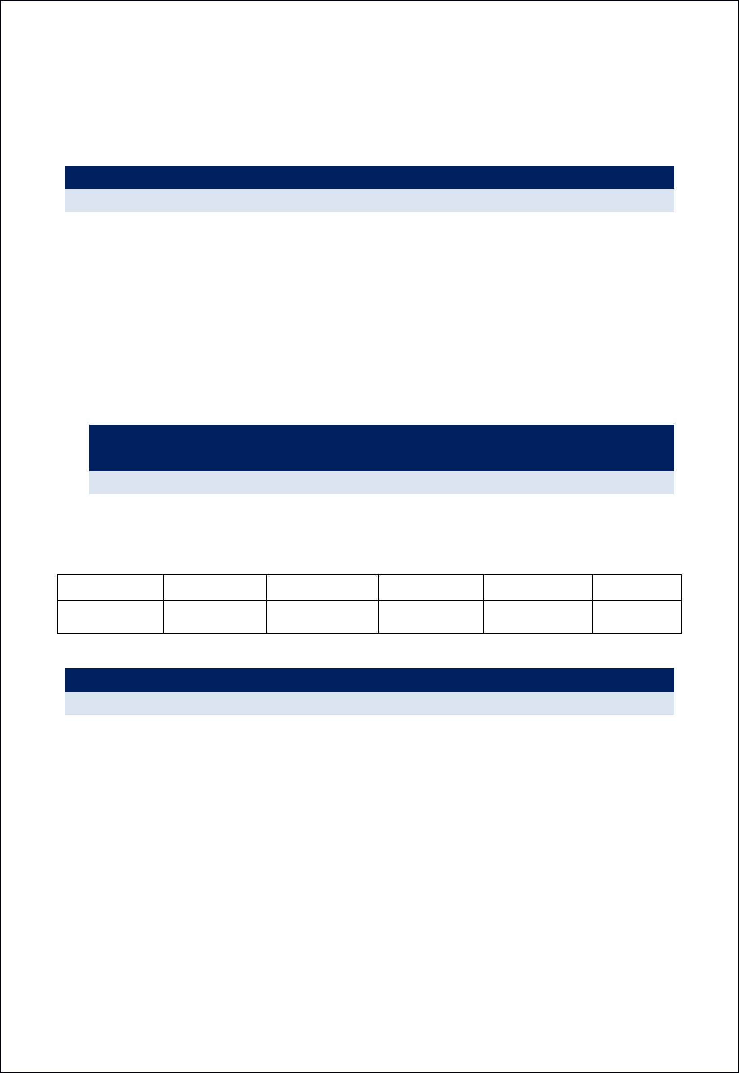
- Prepared construction documents and details to implement design concepts.

- Designed and documented the interiors for Skyline Crescendo, Calicut in 2016, the ineriors of the apartment was published in Indogulf edition of Interior Plus Architecture magazine, 2017 January Edition.

Skyline Builders, Calicut, Kerala September 2010 onwards to May 2015
Interior Designer at Skyline Builders, Calicut & Kannur Branch

- Consulted with clients to determine architectural preference to meet overall design goals.

- Monitored orders using the retail point of sale (POS) system

- Assisted clients with budget considerations regarding products and materials.

- Meet with clients, determine their preferences and develop a budgeted work plan

- Fabricate at least three AutoCAD supported rough sketches for each project and present the same for client approval

- Purchase required materials and hired required personnel based on project

- Collaborate with architects and contractors during construction regarding special considerations based on the approved plan

- Carryout all project related documentation and maintain a project file

  - Main Projects Handled with Skyline Builders, KeralaSeptember
2010 onwards to May 2015
      - As Interior Designer at Skyline Builders, Calicut Branch

    - Designed and documented the interiors for Skyline Heirloom, Kannur in 2012, the ineriors of the apartment was published in veedu magazine.

    - Designed interiors of individual Apartment at Skyline Builders, Calicut & Kannur

Calicut : Garnet Onyx Oceanic Petal Crescendo

Kannur: Cliffwaters Heirloom

Naseem Architects - Manjeri April 2009 onwards to April 2010
Assistant Interior Designer
- Determined functional requirements of the clients and planned the space accordingly.

- Provided programming services for interior design projects.

- Monitored installation schedules with vendors and service providers.

Education

1. Advanced Diploma in Interior Designing from BSS, Govt. of India in the year 2008-2009

 |  | Art & Graphics |  |  |  | Residential |  |  | Computer |  |  | Interior Services
 |  |  |  |  |  | Design |  |  | Aided
 |  |  |  |  |  |  |  |  | Design
Basic concept of Interior design |  |  |  |  | Dining, Living Room, |  |  | Auto CAD & MS |  |  | Lighting, Plumbing, Ventilation
 |  |  |  |  | Kitchen, Toilet ect. |  |  | Office
Colour, Texture & Style |  |  |  |  | Furniture & Fixtures |  |  | 3DS MAX |  |  | Interior Textiles & Fabritecture
 |  |  |  |  | Design
Drawing Techniques & Perspective |  |  |  |  | Office Design
Views
Estimating & Budgeting |  |  |  |  | Villas & Building
 |  |  |  |  | Designs

- COMPLETED HIGHER SECONDARY EDUCATION IN YEAR 2005-2007
- Completed High School Diploma MSNSSHS – NILAMBUR in the year 2002-2005

Additional Information

Date of Birth: 27th December 1989 ~ Languages Known: Malayalam English and Hindi
Nationality: Indian, Marital Status : Married

