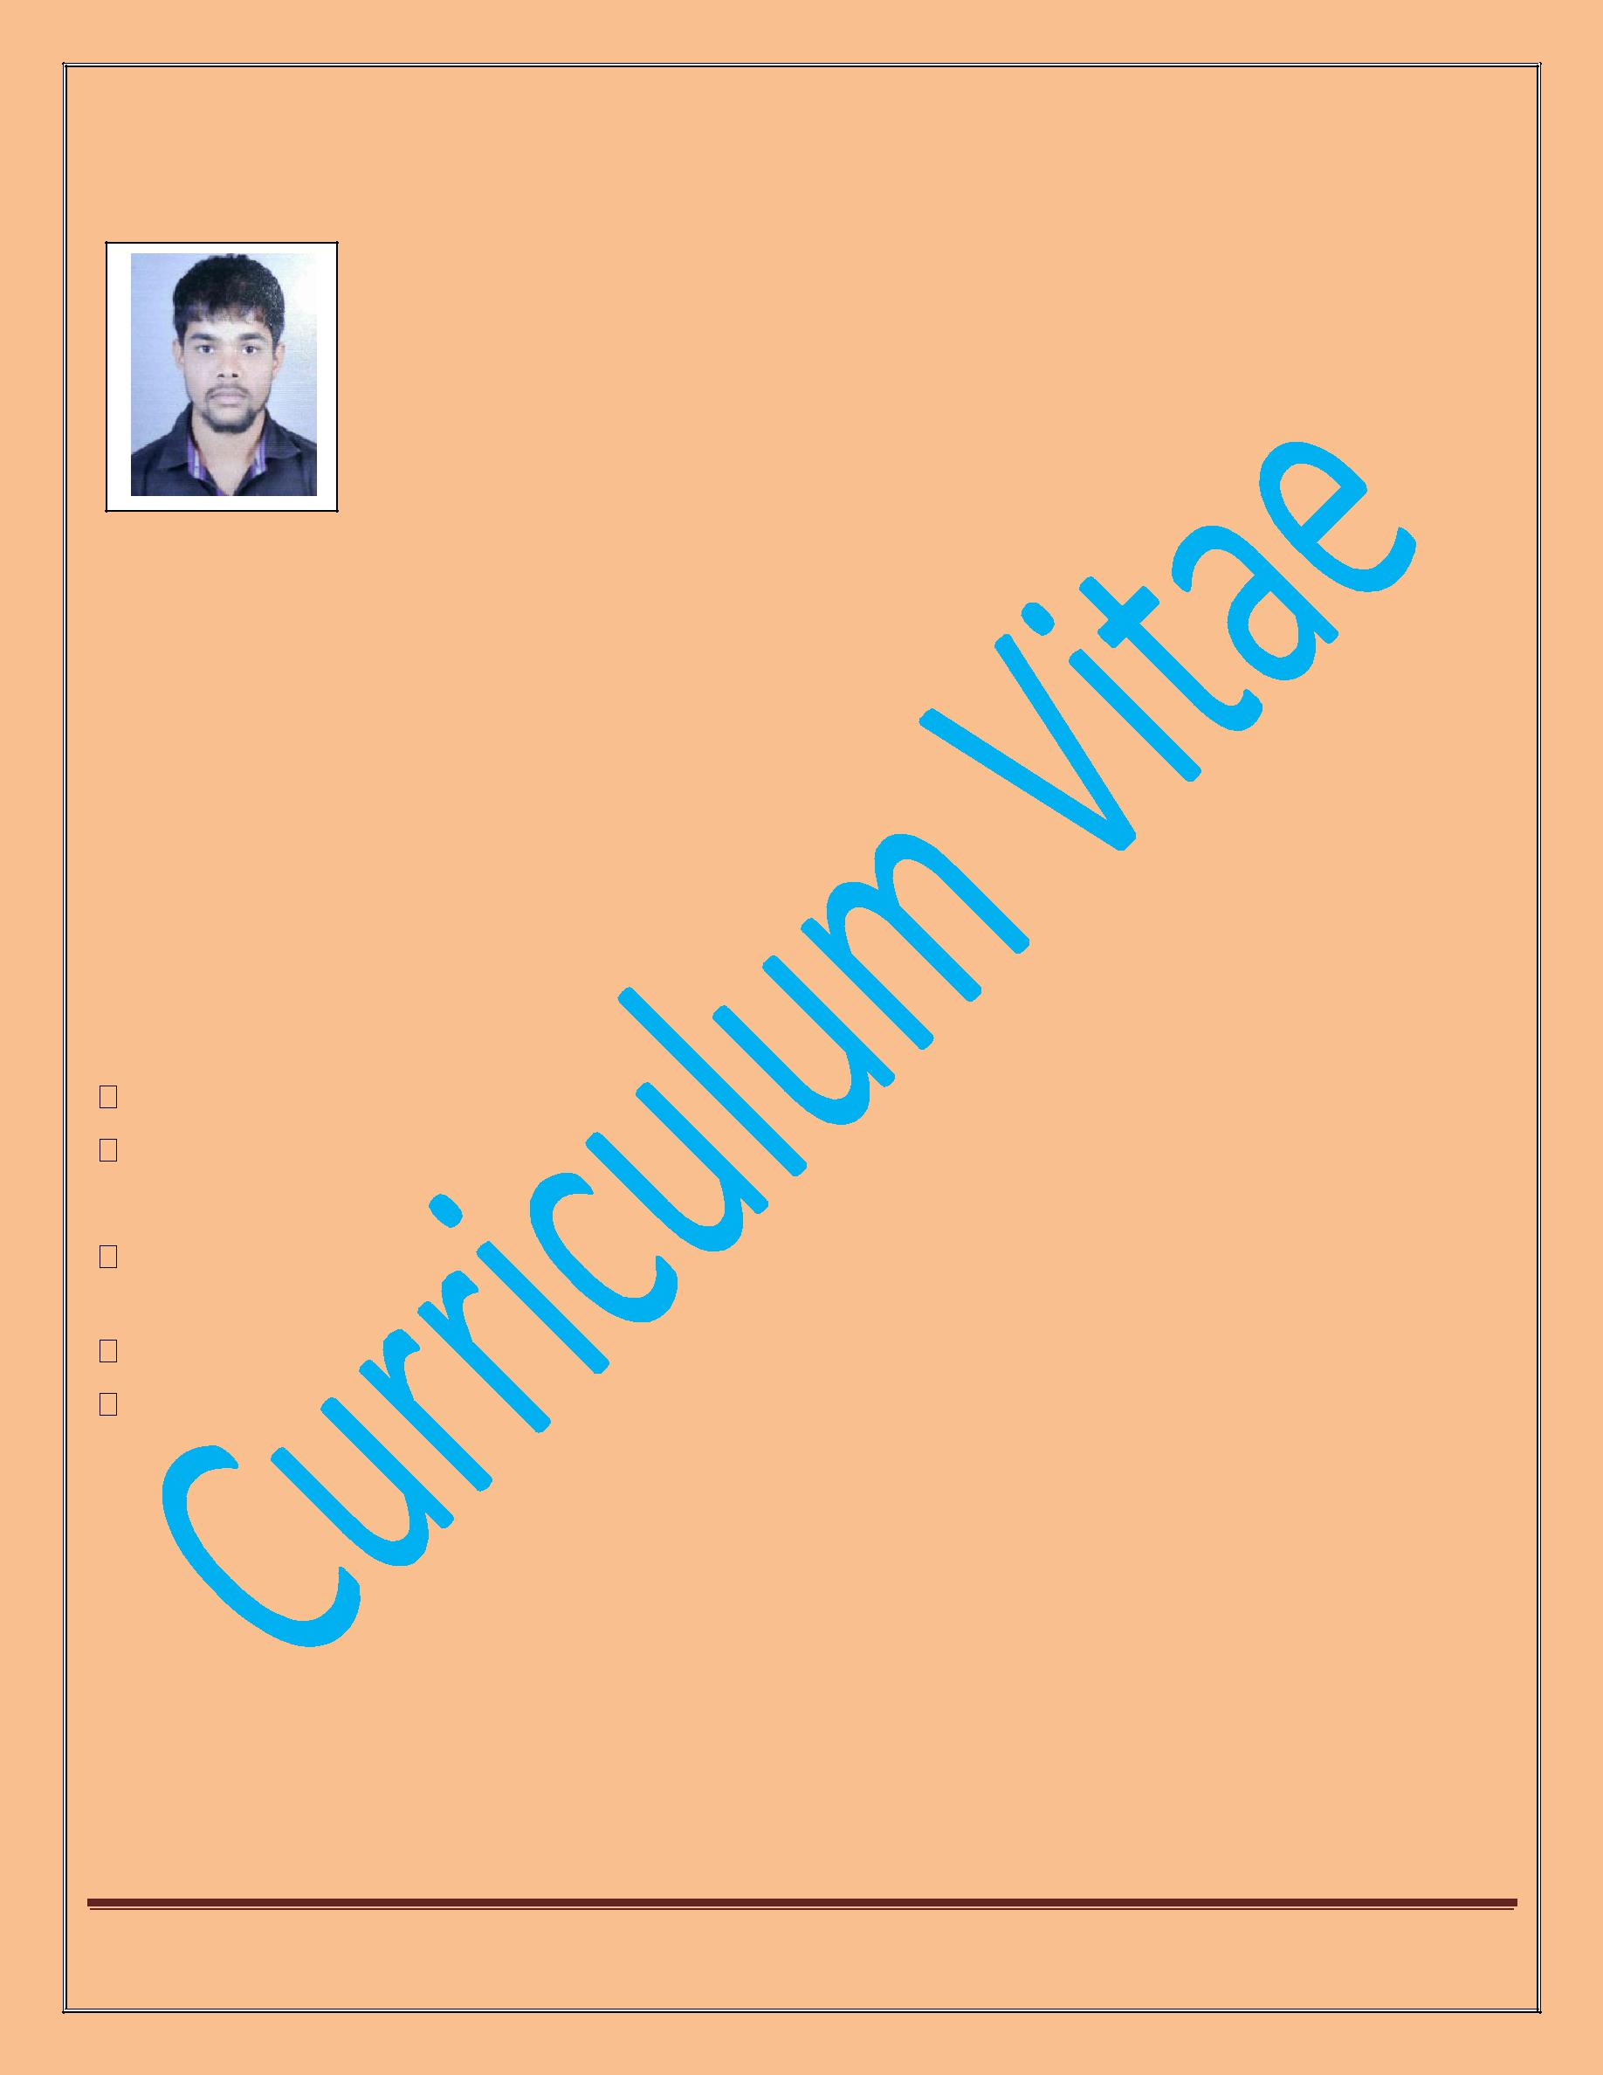
Curriculum Vitae

Pravin
Email: Pravin.379952@2freemail.com
(Deaf & Dumb )

My Introduction:

Looking for an opportunity where I can employ all my skills for the benefit of the Organization. Well skilled, followed by internship like to achieve, Good progress in my career through all my best knowledge and great efforts. If have to Disability Certificate .

Key Skills

Ability to work hard with responsibility

handle all the Store work

Strengths

Enthusiastic and hardworking.

Possess Positive attitude.

Work Experience:

- 4 years- Montfort Integrated Educational Centre, Takli, Patansawangi, Saoner, Nagpur Role: Store Keeping and Asst.Warden.

Page 1

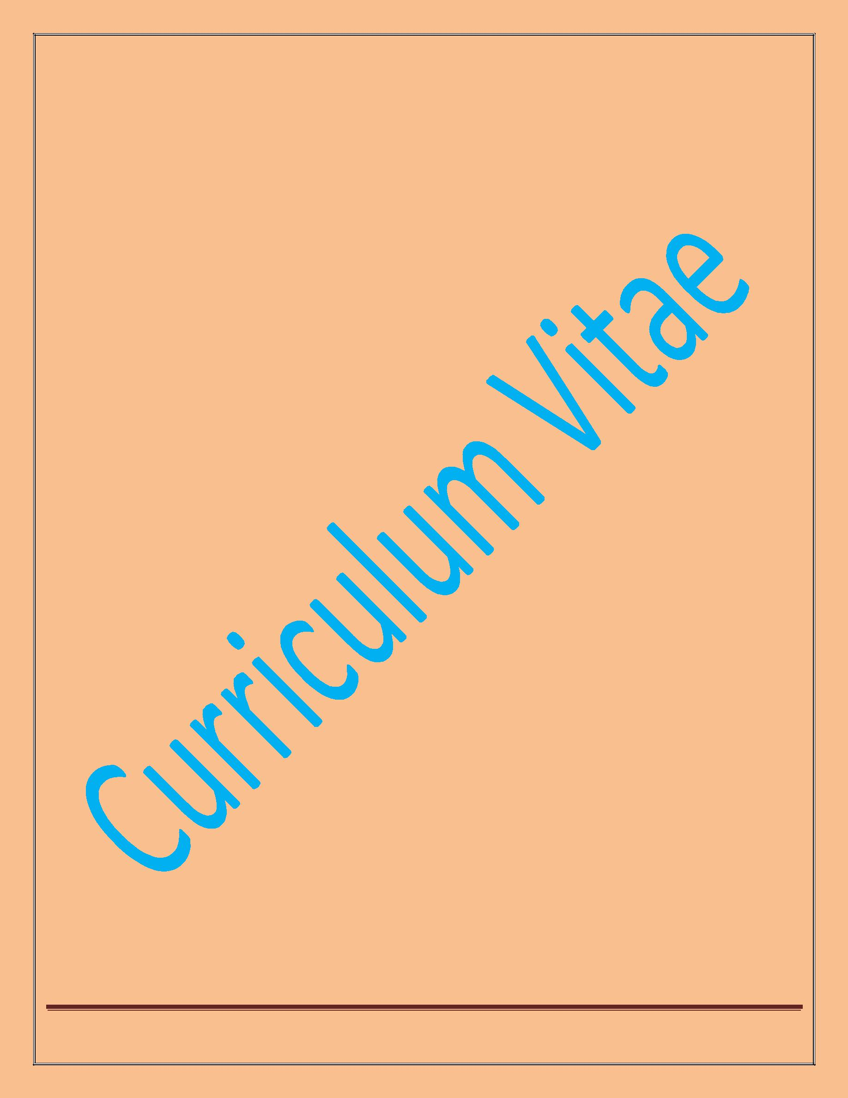
Curriculum Vitae

My Educational Qualification:

H .S.C | - | NIOS Nagpur | 2017
S.S.C | - | NIOS Chandrapur | 2013

My Other Education:

Certification | - | Electrical and Hotel Management (3 Months)
My Personal Information:
Date of Birth | - | 23.11.1994
Age | - | 23year
Birth of Place | - | Ahmednagar
Marital Status | - | Single
Country | - | India
Joining Period | - | 1 Month
Disability Certificate | - | Hearing Impairment (Deaf)

Page 2

Curriculum Vitae
My Declaration:

I hereby, solemnly declare that all information mentioned here above are true.

Thanking You,

Date: / /20

Page 3

Curriculum Vitae

Page 4

