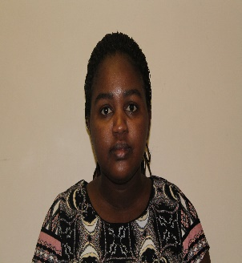

Email
Hellen.379977@2freemail.com
Marital status
Married
Nationality
Zimbabwean
Proficient Language(s)
English
Date of Birth
15 November 1988

Skills
- Good communication and interpersonal skills.
- Excellent organisational skills.
- creative and able to solve problems individually and as a team player
- Able to work in a multicultural environment and establish harmonious and effective working relationships
- Able to prioritise and organise own workload with good decision making skills
- Have knowledge of computers, the internet, and commercially available library software
- Able to think analytically and to develop new or revised systems, procedures, and work flow.
- Desire to meet and serve the library's user community.
- Able to make administrative decisions, interpret policies, and supervise staff
- Able to develop and implement library programs and services
SCHOOL LIBRARIAN
HELLEN

Career Prospects
A very hardworking, skilled and knowledgeable librarian who has excellent up to date experience with all types of media, curriculum design and planning. Have thorough knowledge on library practices and standards and is very passionate about creating a love of reading in all library patrons. Have an honors degree in Library and Information Science with more than five years of experience working as a School Librarian. Able to prioritise and organise own workload with good decision making skills.
Professional Experience
Librarian – Education Library Service, Ministry of Education, Arts and Culture, Namibia (April 2016 to present)
- Cataloguing and classification of library materials
- Selection of instructional school library supportive material
- Implementation of school library reading promotion programs in schools
- Literacy; assist in evaluating and monitoring the functioning of school libraries countrywide
- Monitoring use of the ICT tools provided to schools by the office.
- Assisting with the computerization of school libraries and provide training
- Supervising processing and the redistribution of books and periodicals
- Managing the office Facebook page
Achievements
- Compiled an annual newsletter
- Organised a National Readathon with the First Lady of Namibia in attendance
Librarian - Amazing Kids Private School Academy, Windhoek, Namibia (March 2014 to January 2016)
- Teaching Basic Information Science to Grade 5-10
- Collecting and promoting informational resources that support the school’s curriculum.
- Communicating with students and helping them find what they need through the use of e-resources and physical books.
- Selecting and ordering library material within the educational guidelines of the school.
- Putting together and maintaining schedules for instructional programs by working hand in hand with other staff members.
- Shelving
- Database Management
Achievements
- Created and designed the library from scratch
- Learners celebrated Readathon once every school term
Professional and Academic Qualifications
- Bachelor of Science (Honors) Degree In Library and Information Science, NUST(2011)
Degree class 2.2
Advanced level – Chiredzi Christian College (Southern Africa)
Ordinary level – Mount Selinda High school (Southern Africa)
Professional Body–Namibia Information Workers Association (NIWA)
Referees
- Available Upon Request
- Available for Relocation

