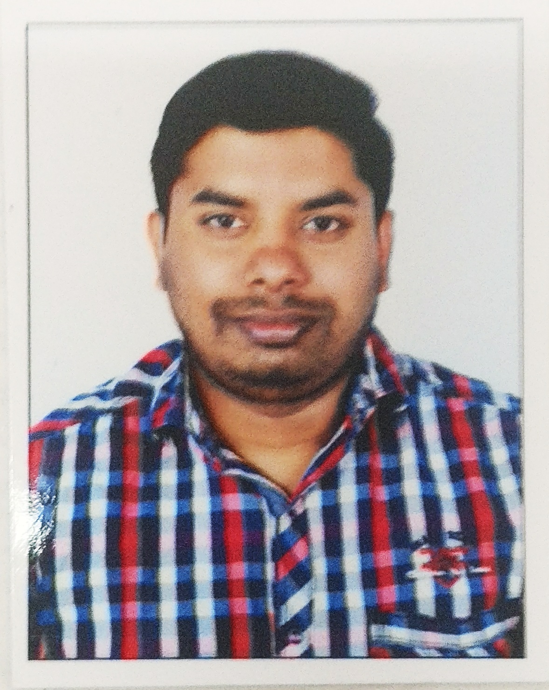
- RESUME

NIAZUDIN

E-mail:- niazudin.379988@2freemail.com

Career Objective:-
I have worked in the managerial category, with special emphasis on handling the day to day administrative activities of the company. In my role with the present employer, I intend to evolve into a more rounded professional, using the skills that I have obtained from my past experience. Ability to work in a team striving in a high pressure environment was a valuable skill that I picked up apart from the uncompromised deadlines.
Work Experience:-
Company Name: - Al mahar DIESEL L.L.C (U.A.E., FUJAIRAH EMIRATES) (From October 2015)
I have started working as an Accountant with the above company in the year 2015, and gradually promoted to the grade of assistant manager level. During this tenure of service, I had handled the following tasks.
- The above mentioned company have sister concern in the name of oriental Diesel L.L.C
& Its accounting jobs also handled. By using Tally E.R.P 9
- Handled all bank related jobs, such as statement review, issuance and clearance of cheques, keeping updates of all transactions in the system.
- Handled Tally E.R.P 9 accounting system & Also Handles P.H.P Online software system.
- Assisted in preparation of yearly statements such as balance sheet, income/revenue and expenditure statements.
- Handled all payments for the company, issuance of invoices and delivery notes for the suppliers.
- Preparation of wages/salary statements for staff and keeping an update of all debtors and creditors.
- Co-ordinating with the labour .
- Handling of office licence renewal and submitting the annual returns for the factory.
- Keeping time management, leave records, payroll administration and general administration.
- Handling of company’s petty cash for various local purchases.
- Distribution of various tasks to staff and labours, appraisal of staff and recommendation for increment.

Company Name: - Madhar Kulsum Tanners, Chennai (From April 2010 – July 2015)
I have started working as a Computer Operator Cum Accountant Assistant with the above company in the year 2010, and gradually promoted to the grade of supervisory level. During this tenure of service, I had handled the following tasks.
- Remittance of monthly returns to Providend Fund and E.S.I offices.
- Handling of office licence renewal and submitting the annual returns for the factory.
- Assisted in preparation of yearly statements such as balance sheet, income/revenue and expenditure statements.
- Liaisoning/communicating with the Pollution Control Board, Providend Fund, Employee State Insurance Offices, State Electricity Board and the Telephone Department.
- Handled peach tree accounting system.
- Handled all payments for the company, issuance of invoices and delivery notes for the suppliers.
- Distribution of various tasks to staff and labours, appraisal of staff and recommendation for increment.
- Handled all bank related jobs, such as statement review, issuance and clearance of cheques, keeping updates of all transactions in the system.
- Keeping update of machineries and generators of the factory, fire licence renewal and industrial health and safety returns.
- Preparation of wages/salary statements for staff and keeping an update of all debtors and creditors.
- Co-ordinating with the labour contractors and machinery operators.
- Keeping time management, leave records, payroll administration and general administration.
- Handling of company’s petty cash for various local purchases.
- Involved in client orientation on a regular basis.

Company Name: - Oriental Supermarket W.L.L, Bahrain (2009 to 2010)
Worked in the above company as a Billing Clerk and handled the following tasks.
- Acted as a billing agent for all the customers.
Educational Qualifications:-
B.com from Calicut University in specialization in financial accounting in the year (2004 to 2007).

Computer Skills:-
Proficient in MS office, Word, Excel, Power point, Outlook and browsing of internet. Knowledge of Tally 7.2 and peach tree.

Personal Details:-
Name : - Niazudin
Date of Birth : - 18-Decembr-1986
Marital Status : - married
Languages Known:-
Language Read Write Speak
Malayalam Yes Yes Yes (Mother tongue)
English Yes Yes Yes
Hindi Yes Yes Yes
Tamil Yes No Yes
Arabic Yes Yes No
Strength:-
Interpersonal and team skills
Hard working and committed
Innovative mind
Good communication skills
Open minded and polite
I hereby declare that the information given above is true to the best of my knowledge and belief.
NIAZUDIN
Place:-
Date:-

