MECHANICAL ENGINEER

PRAVEEN
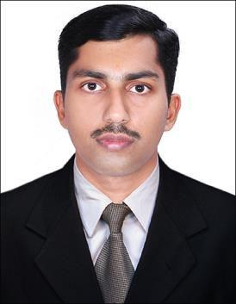

Email:

Praveen.380002@2freemail.com

Personal Details:

Date of birth : 09/05/1992

Age : 26

Sex : Male

Languages known:

English, Malayalam,

Hindi

Nationality : Indian

Marital Status : Single.

OBJECTIVES

Seeking a challenging position in a reputed institution where I can utilize my skills and gain international standard of the same. I will be able to prove myself as a strong and effective contributor to the organization with a strong drive to achieve my personal and professional goals.

STRENGTHS

- Excellent to be a part of the team.

- Able to understand and carry out policies and procedures.

- Strong work ethics and positive attitude.

- Good interpersonal and Communication Skills.

- Excellent drawing skills.

- Excellent skills in mechanical software.

EDUCATIONAL DETAILS

- Bachelor of Technology in Mechanical Engineering from Kannur University, Kerala, India (2014).

- Master of Technology in Thermal and Fluids Engineering from APJ Abdul Kalam Technological University, Kerala, India (2017).

PROFESSIONAL CERTIFICATION AND TRAINING

Certified in HVAC DESIGNING AND DRAFTING by Scientific and Technical Education Development Council, Kerala, India

• Estimating heat/cooling load, CFM calculations, infiltration, ventilation using ASHRAE standards

- Sizing of ducts and pipes, developing their drawings and preparing technical documents

- Transmitting information into CAD and producing relevant drawings.

COMPUTER KNOWLEDGE

- Mechanical Design & Analysis Software: Auto CAD, ANSYS, NX CAD, Pro E, Fluent.

- Programming Language: Fortran, C program.

- Other software: MS Office, Adobe Photoshop.

M.TECH THESIS

- Finite volume analysis of energy release in a packed bed thermochemical reactor.

PROFESSIONAL EXPERIENCE

- Worked as Lecturer in Mechanical Engineering Department, Swami Nithyananda Poly Technic College, Kanhangad, Kerala, India from November 2014 to March 2015

AREAS OF INTEREST

- HVAC Engineering.

- Computational Fluid Dynamics (CFD).

- Thermal Engineering.

- Production Engineering

DECLARATION

I hereby declare that the above furnished particulars are true to the best of my

knowledge and belief.

PRAVEEN

