.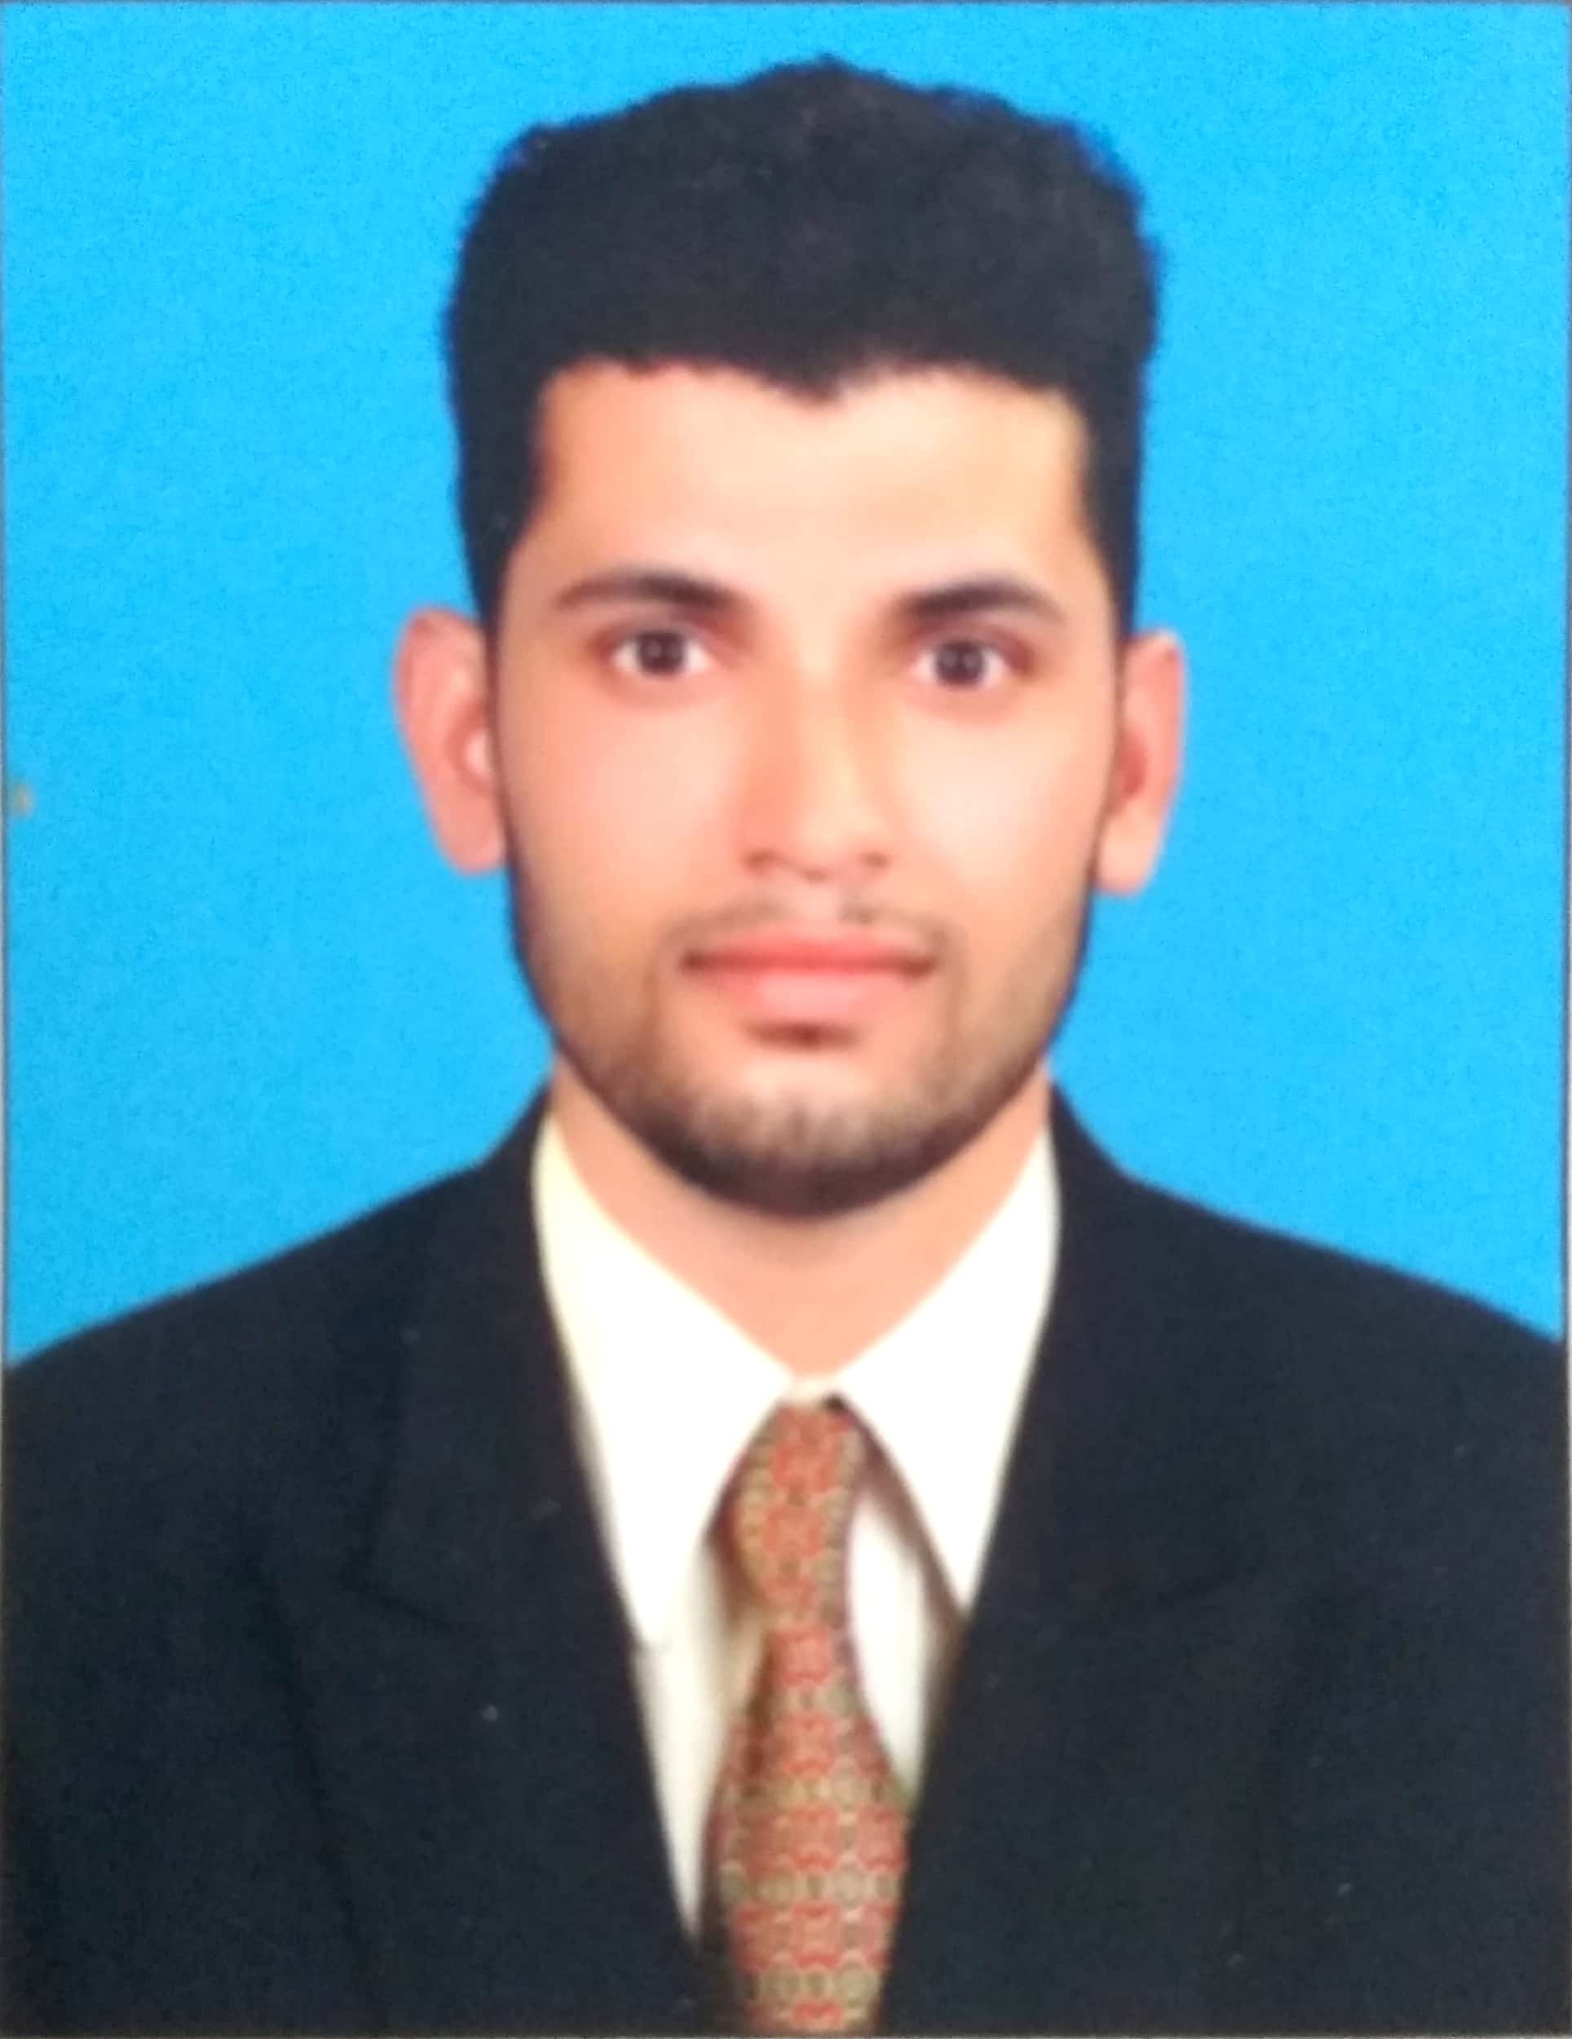
VINITH
Email:
Vinith.380004@2freemail.com

Personal Details:
Date of birth : 02/06/1991
Age : 27
Sex : Male
Languages known:
English, Malayalam, Hindi
Nationality : Indian
Marital Status : Married.
OBJECTIVES
Seeking a challenging position in a reputed institution where I can utilize my skills and gain international standard of the same. I will be able to prove myself as a strong and effective contributor to the organization with a strong drive to achieve my personal and professional goals.
STRENGTHS
- Excellent to be a part of the team.
- Able to understand and carry out policies
and procedures.
- Strong work ethics and positive attitude.
- Good interpersonal and Communication Skills.
- Excellent drawing skills.
- Excellent skills in survey project
EDUCATIONAL DETAILS

- Bachelor of Science in Geography from Kannur University, Kerala,
India (2012).
- Master of science in Geography(Geo informatics) swami Anandhatheertha campus payyanur campus Kannur university Kerala ,India(2015)

COMPUTER KNOWLEDGE

- TALLY : Indian Accounting

- Other software: MS Office,

PROFESSIONAL EXPERIENCE
- Worked at UL Technology solution pvt cyber park Kozhikode GIS Field Engineer, Kerala, India from August 1st 2016 to March 23rd 2018.

DECLARATION
I hereby declare that the above furnished particulars are true to the best of my knowledge and belief.

VINITH

