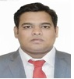
Curriculum Vitae
Saif
Contact: saif.380018@2freemail.com
Visa Type: Visit Visa | Visa Expiry: 4th July 2018

PROFESSIONAL EXPERIENCE
Obtain a position in the industry that utilizes a bland of my 4 years’ experience in sales and marketing, business development, marketing, sourcing, procurement, merchandising, logistic monitoring and quality control at its fullest.

AREA OF EXPERTICE
- Sales and marketing, Retail sales, Sales Promotion, Campaign Management, Supply chain Management.
- Customer Service, Operation Management, Technical knowledge of System, MIS, ERP, CRMs and Cannels, Brand Management, Digital Marketing, Product Management, Category Management.
- Manpower Handling., Computer Literate, Time Management, MS- Office- word, Power point
ACADEMIC CREDENTIALS

Master of Management Studies (MMS in Marketing) /MBA)-
2017 | Aditya Institute of Management Studies and Research, Mumbai, India.

Bachelor of Computer Application (BCA)-
2012 | Deogiri College, Aurangabad, India.

EMPLOYEMENT HISTORY
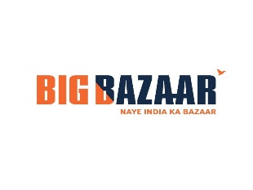

Organization: Big Bazaar (Future Group), Mumbai, India.
Designation: Assistant Manager
Tenure: Sept 2017 to March 2018

Handling all category FMCG and confectionary, utensils, IT zone, Fashion zone, Cutlery and note books, Maintained and restocked inventory as well as POS system, Resolved customers service or billing issues promptly while providing exemplary Customer Service, managing stock availability throughout the supply chain, from suppliers to stores, Monitoring stock levels and reviewing product performance in order to identify current and future trading opportunities, coordinated among all supply chain and production unit to ensure on time delivery, maintain knowledge of current promotions, policies regarding payment exchange and security practices into database.
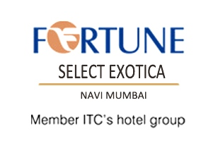

Organization:Fortune Select Exotica (ITC Group),Navi- Mumbai, India.
Designation:Assistant Sales Manager.
Tenure: August 2016 to September 2017.

Follow up new business opportunities and setting up meetings with Corporate clients, communicating new product developments or service to prospective clients, Negotiating and closing the deals, writing reports, providing management with feedback, identifying new sales leads, to plan and execute a daily system of sales calls on travel agents, Airline Offices, Commercial Houses, Industrial and professional associations, diplomatic missions. make regular sales calls and maintain a systematic record of sales calls made. maintain good PR with Corporate, TAs and all other business generating sources, compile and maintain a mailing list for the dispatch of promotional material, handle telephonic enquiries as per standards laid down, report backs and other follow-ups.
Organization:Aquasmith Water Solution Pvt Ltd, Mumbai, India.
Designation:Sales and Marketing Intern.
Tenure: May 2016 to July 2016 (only 2 month’s)

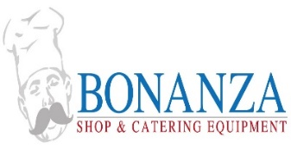
Supervising sales team at the assigned territory, establishes team and individual sales goals and e, analyze sales data to identify opportunities for increased productivity and sales on both a group and individual level, Demand forecasting, providing training to salesman about product as well as how to convert a sale, making promotion of product ATL and BTL,creates daily, weekly, monthly activity and productivity reports, Organized different Campaign for awareness of brand positioning in market. Branding of company with visual merchandising, Handling Digital marketing campaign like Social Media marketing as well as email marketing. Handle, Manage, communicate with business partner and distributors to solve queries, making presentation and represent in front of board members.

Organization:Bonanza Shop & Catering EquipmentServices, Mumbai, India.
Designation:Business Development Executive.
Tenure: June 2014 to July 2015

Assess and identify new opportunities through market research and tie up with potential prospects to generate leads, Identifies, qualifies and solicits new catering business to achieve personal and hotel revenue goals, use negotiating skills and creative selling abilities to close on business and negotiate contracts, Responsible to bring in corporate orders from Hospitals, offices, schools, corporate and tourism Companies, Manages sales efforts for the hotel including local corporate and social catering, Responds to incoming catering opportunities for the hotel and equipment.

Organization: Qualsoft System Pvt Ltd, Mumbai, India.
Designation: Business Development Executive.
Tenure: July 2012 to May 2014

Calling to Client’s and Meeting with clients, offering different product of QSPL into the market with variety of range products, Visiting B2B marketing to the corporate for cold calling to sale product like E-learning solution as well as biometric solution also barcode solutions, Closing the deals of software products like hospitality software, e-schools, e-college, E-learning, SaaS Application, Biometric S/w, Barcode solution of cloud computing System, Prospect Identification, Nurturing & Closure Lead Management, Independent Sales Target, New Business Acquisition only (Account Management), Penetrate target accounts and uncover new companies/stakeholders.

PERSONAL INFORMATION

Nationality:Indian.
Religion:Muslim.
Gender: Male.
Language:English, Hindi, Marathi.
Marital Status:Single
Declaration
I declare that all the information above is correct and references are available if they are needed hoping that my experience will be useful to you. Yours Sincerely

