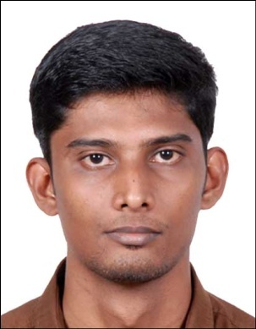  ARUN  Contact Details:  Email : arun.380041@2freemail.com  Nationality:  Indian  Date of Birth:  02-March-1991 (27 Years)  Languages Known:  English, Malayalam, Tamil  Personal Details:  Sex : Male  Age : 27 years  Marital Status : Single  Hobbies:  Playing Badminton, Cricket, Listening to music | CAREER OBJECTIVE  Seeking a position as an Office Administrator. To work in a challenging and dynamic environment, which gives me an opportunity to add value to the company and enhance my knowledge and continuous development of upgrading knowledge by execution of vested responsibilities by the organization with loyalty and integrity  Profession:Office Administrator  An Office Administrator Assistant with 2 Years and 11-month experience in reputed organizations in India. Performed office administrative tasks such as Managed daily office operations, planning and coordinating meetings, handling office mails.  Career Summary  - Following standardized company procedures relating to all aspects of Office performance.  - Answering incoming calls in a professional manner.  - Resourcing of candidates and appropriately advertising for and recruiting place able staff.  - Sourcing candidates C. V’s from various job boards or other media sources.  - Arranging interviews and confirming interviews by email.  - Managed daily office operations, planning and coordinating meetings, handling office mails  - Payroll management  ACADEMIC PROFILE  - M.Sc. in Computer Science, with an aggregate of 54% in the year 2012-2014 from College of Applied Science, Mahatma Gandhi University.  - B.Sc. in Computer Science, with an aggregate of 64% in the year 2008-2011 from College of Applied Science, Mahatma Gandhi University.  - Pre-Graduation –with an aggregate of 78% in the year 2008 - Board of Higher Secondary Examination - Kerala – India  - Matriculation – with an aggregate of 73% in the year 2006 - Board of Public Examinations - Kerala – India  SKILLS  Technology: C#.Net, Asp.Net 3.5, Basics of C and C++,  HTML 5  DBMS: Microsoft SQL Server  Operating System : All Windows Versions.  - Tally (basic)  - Well knowledge in Up to date Hardware and software changes  - Maintain IT equipment’s  - Take inventory of IT equipment and Organize IT equipment’s storage.  - Train Users in the operation of the new changes.  - Software/Hardware installation, configuration, Upgrading.  - System Protection (Virus, intruders, Trojan, malwares)  Computer Exposure  - Have experience and expertise in installation of various software andOperating systems namely Windows UNIX  - Expertise in the usage of MS office tools namely Word, Ms-Excel,Power point, Ms-Access  - Have Expertise in using search engine tools and internet  Work Experience  Name of Organization Designation Duration of Work  Shalimar Marbles and Granites Office admin April 2015-Dec 2016  Davani Silks Pvt Ltd. Office admin Jan 2017-Feb 2018

DECLARATION
I hereby declare that the above mentioned are true to my knowledge and best of my belief.
Place: Dubai Arun

