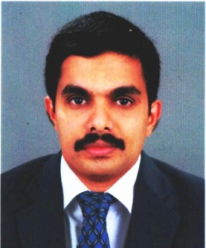
Ershad
Contact: ershad.380042@2freemail.com
Profile
Prove to be an asset by playing a major role in the prosperity of the company and the growth of myself.
.................................................................................................................................................................................................
Professional Demonstrated continuous effort to improve operations, decrease turnaround times,streamline
Strengths work processes, and worked cooperatively.

Abilities in handling multiple priorities. With a bias for action and a genuine interest in professional
development.

Notable Interpersonal skills, capacity to relate to all levels of management, staff and customers
………………………………………………………………………………………………………………………………………………………………………….……………....
Education

Technical Diploma in Hotel Management
INTI International College, Genting - Malaysia

Academic Post Graduate Diploma in Business Management
Oxford College International, London - UK
Master of Business Administration (Human Resources Management)
London College of Computing and Management, Preston University, London - UK
……………………………………………………………………………………………………………………………………………………………………………………………
Experience Worked as Operations Manager in Renai Blue Waters Cherai 2016-2017
Worked as Assistant Manager Banquets in Indian Medical Association Cochin2014-2016
Worked as Restaurant Manager in Fresh and Spot Restaurant in Dubai 2012 - 2013
Worked as Restaurant Manager in Kovalam Indian RestaurantLondon – UK2009 – 2011

- Responsible for day to day operations
- Assist & Report to the F&B Manager for all food and beverage activities
- Developing and implementing promotions
- Developed repeat business by establishing close & lasting relationship with customers
- Maintained 100% compliance to all standards – satisfaction, safety, quality & service

Personal DOB: 27 May, 1986 / Married / Indian / Muslim
Hessa building,Deira ,DUBAI

LanguageEnglish, Malayalam, Tamil and Hindi
……………………………………………………………………………………………………………………………………………………………………………………………

References Upon request

