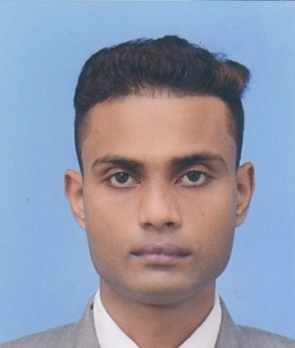
RANATHUNGA
SRI LANKA.
Email: ranathunga.380048@2freemail.com

ACADEMIC QUALIFICATIONS :
Saranath M.V,Kuliyapitiya,Sri Lanka (2014)
G.C.E. Advanced level (Sinhala medium)

  - Physics S
  - General English S
  - General Knowledge test 38

Pannala National School,Pannala,Sri Lanka (2011)
G.C.E. Ordinary level (Sinhala medium)

- Buddhism A
- Sinhala Language & Lit. A
- History B
- English C
- Mathematics C
- Science C
- Geography C
- I.C.T. S

ACHIEVEMENTS & CERTIFICATES:
- I have successful completed Higher National Diploma in National Institute of Business Management (NIBM) Sri Lanka. {special knowledge for computer assembling,hardware and repairing}
- Certificate in MOLECULAR GENETICS (University of Sri Jayawardenepura).
- Certificate in Daham School Examination(Kithalahitiyawa Sri Sarananda Daham School) Sri Lanka.
- Certificate in Drama events.
- Certificate in Cricket events.
- Certificate in School Sports meet Event.

Working Experiences:
- I have one year working experience as a Supervisor & Purchasing Officer at DCRC (Dinoja Collision Repairing Center) in Sri Lanka. (2014.09.02 - 2015.10.15)
- I have one year working experience as a Air ticketing executive at Sumaga Travels & Tours in Sri Lanka.(2015.10.25 - 2016.11.01)
- I have one year working experience as a Cashier & Sales Manager at City Communication and Phone Shop,Pannala,Sri Lanka.(2016.12.10 - 2017.12.29)
PERSONAL INFORMATION :
Date of birth : 17.08.1995
Age : 23 years
Gender : Male
Civil status : Single
Nationality : Sri Lankan
Schools attended : Giri/Pannala National School
Kuli/Saranath Maha Vidyalaya

I certify that the above information are true & correct to the best of my knowledge.

......................................................... .........................................................
Date Signature

