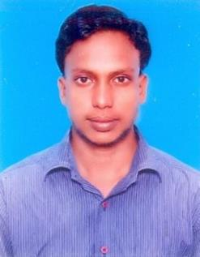  NAME | : | DR. RAJKUMAR
E- mail id | : |  | Rajkumar.380049@2freemail.com
Location | : |  | Ajman, UAE

OBJECTIVE

- Seeking an entry level position in a leading Government dental hospital or Private dental clinic In order to improve my dental career

EDUCATION

Bachelors in Dental surgery at Annamalai University 2006 - 2011

WORK EXPERIENCE

- Worked in Mayavaram R K Hospital from (2/5/2011) –(30/4/2012) FROM 2012 June –

2017 March Worked in Latha Dental Clinic and Hospital, Batlagundu Rejoined from (25/04/2017) to (15/02/2018) Worked in

LathaDentalClinicand Hospital,Batlagundu
Experience nearly 6 years.

SPECIALISED SKILLS
Excellent diagnostic skills using clinical knowledge and X-rays

Excellent hand work and communication skills

Good knowledge of clinical practices and protocols -ability to handle different types of patients -flexible and adaptable
Extremely motivated towards career

INTERNSHIP

Conducted IDA camp dental awareness conducted health education
involved various types of cases which

included: Root canal treatment and digital radiotherapy Dental cleanings Composites, amalgam restorative fillings and Completedentures, Fixedpartialdentures,Oral prophylaxis, bleaching. Especially surgical, extractions, clinical crown , Impaction surgery.

ACHEIVEMENTS
Child awareness program -Participated dental program in colleges

Conducted FREE DENTAL HEALTH CHECK UP nearer schools Conducted Dental camp and Treatment planned in villages
40 participated and benefited

PERSONAL PROFILE

Date of Birth :3/09/1988

Gender : male

Nationality : Indian

Hobbies :Reading books, Newspaper and meditation.

