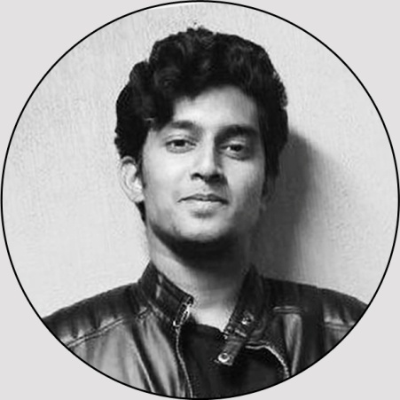

I’m a graduate in architecture looking for unique and interesting opportunities where I can utilize my creative skills as an architect and also improve and learn by working with professionals in the field. I totally love what I do and strive for quality in everything. My main goal is to design quality spaces and their surroundings in the best way possible, plus to always improve my style and to do something different each time.

**THESIS TOPPER -**

**DISTRICT LEVEL:**Have received second place in district level for sketching at higher secondary category.

**I N T E R E S T S**

**M E R I T S**

ARCHITECT

**VIVEK**

**S K I L L S**

**P R O J E C T S** **B R I G A D E T E C H G A R D E N S - T E C H P A R K ( B A N G A L O R E )**The Brigade Tech Gardens vision conceives of a new innovative workplace campus designed with state-of-the-art efficiencies and services in mind. The multi-scaled nature of this master plan with around 2.6lakhs sq.m of office space, provides the campus with “unique, flexible and sustainable” aspirations catered to the 21st century workplace.**K E Y R E S P O N S I B I L I T I E S -** Design coordinator and generation of working drawings.

**-** Infrastructure development and Site coordination.**-** Consultant coordination and solution making. **P R E S T I G E W E S T W O O D S - T O W N S H I P ( B A N G A L O R E )**A township with High-Rise Apartment Complex comprising of 567units of apartments in a

28,935.02 sq.m site.**K E Y R E S P O N S I B I L I T I E S** **-** Finishes package-generation of working drawings**-** Consultant coordination**-** Site coordination**P R E S T I G E V E R D A N T V I S T A - T O W N S H I P ( B A N G A L O R E )**A township with High-Rise Apartment Complex comprising of 97units of apartments in a

4856.23 sq.m site.**K E Y R E S P O N S I B I L I T I E S** **-** Design coordinator.

**-** Infrastructure development.

**-** Design development to sanction stage.

**1)ARCHITECT @ ZACHARIAH CONSULTANTS, Bangalore**  **Oct.2015. - Nov.2017** Worked in various township, commercial and institutional projects.

**2)INTERN ARCHITECT @ SILPI ARCHITECTS ,Kochi, Kerala June 2013 - Dec.2013** Worked in various residential and institutional projects.

**E D U C A T I O N**

Painting **-**Sketching **-**Reading **-**Craft and art **-**Model making **-**Photography **-**

**B.Arch 2010-2015**

**ANNA UNIVERSITY**

**SVS School Of ArchitectureCoimbatoreTamil Nadu**The five years as an architecture student has given me the opportunity to understand architecture, learn and grow as a creative thinker, experiment with my ideas and implement the best of those in various academic projects.

[Vivek.380056@2freemail.com](mailto:Vivek.380056@2freemail.com)

DOB : 31st Dec. 1992

Nationality : Indian

PROFESSIONAL SKILLSAdobe Photoshop **-** Autodesk Revit **-**Lumion **-**Autocad **-**Adobe flash **-**MS office **-**

**P E R S O N A L D E T A I L S**

**C O N T A C T**

**E X P E R I E N C E**