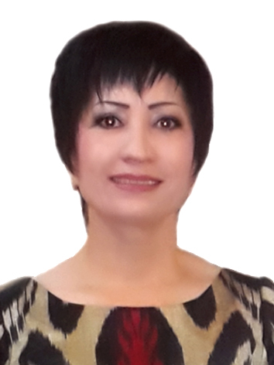
ZUKHRA
Email: zukhra.380059@2freemail.com

PERSONAL INFORMATION
DOB: 28/04/1968
Age: 50
Material Status: Single (unmarried)
Nationality: Uzbek
Gender: Female
Languages: English, Russian, Uzbek

OBJECTIVES

Seeking a Massage Therapist position in a company where I can utilize my extensive clinical and teaching skills, and be rewarded within an environment that strives to provide excellent patient care.

QUALIFICATIONS SUMMARY

- Experienced massage therapist dedicated to providing quality therapeutic massages and educating people on overall health and wellness.
- Succeeded in building an efficient private practice while working alongside other massage therapists.
- Able to uphold moral ethics to help promote a positive view on the industry.
- Established and maintained excellent client relationships to ensure higher number of repeat clientele.
- Instructed clients in proper care and helped individuals take steps to improve their health.
- Qualified in: Chair massage, Russian massage, Swedish Massage, Therapy deep tissue massage, Relax massage, Turkish peeling and foam massage, Stone massage, Thai massage, Sports massage, Vacuum massage, HealthCare massage, Aroma massage, Cellulite massage, Child massage,

EDUCATION

- “Sport and Physical Training University of Russia” Russian Federation Sep 2008- March 2010
Faculty:Masseuse and SPA therapist.
- “IkbalKamalagi” Private Learning CentureApril 2010 – August 2010
Curriculum: Nurse

PROFESSIONAL EXPERIENCE

MIRAN INTERNATIONAL 5* HOTEL - Uzbekistan, TashkentJune 2014 –till present
Massage Therapist
- Provided massage services to clients using safe, appropriate and effective techniques.
- Performed health history on clients and updated prior to each session; ascertained precautions/contradictions for massage prior to each session.
- Explained procedures and applied techniques appropriate to client needs and preferences.
- Observed client reaction to massage and modified as necessary.
- Solicited feedback and responded accordingly.
- Documented all sessions performed according to established guidelines.
- Other responsibilities included: Maintaining client confidentiality and sensitivity to age and gender related issues during all client interactions; reporting any unusual client interactions to supervisor immediately, scheduling and maintaining appointments; assisting in collection of fees, consulting with appropriate treatment staff regarding treatment plans when necessary.

RADDISON BLU INTERNATIONAL HOTEL –Uzbekistan, Tashkent April 2010 – June 2014
Massage Therapist
- Provide professional massage to guests with 25, 50 and 100 minute prior to appointment.
- Establish and ensure to break down allotted massage room prior and subsequent to shift completion.
- Maintain massage room with supplies and ensure neatness across shift.
- Comply with all procedural guidelines pertinent to massage therapy and interact nicely with guests.
- Provide safe, suitable and effectual massage techniques.
- Explain method and applicable techniques appropriately to customer needs as well as preferences.
- Ensure to observe customer reaction to massage as well as modify as required.
- Elicit feedback on given massage therapy and respond accordingly.
- Maintain confidentiality as well as sensitivity related to age plus gender during client interactions.
- Reports any unusual customer interactions to supervisor promptly.
- Head responsibility to clean and maintain massage rooms, changing linens and refilling supplies etc.
- Provide comfortable plus relaxing spa experience to all guests ensuring extreme safety for guests.
SPASALOON“Я”RUSSIAN FEDERATIONSep 2008 – March 2010 MassageTherapist
OTHER COMPETENCIES
- Computer literacy: Microsoft Office (Word, Excel, PowerPoint, Outlook, Access, Publisher),

