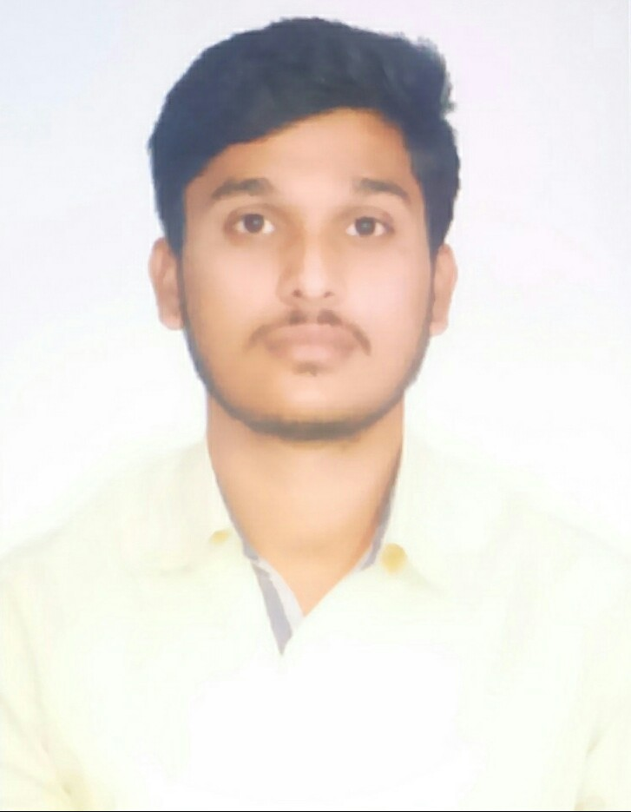
PRANAV.
Pranav.380080@2freemail.com

CAREER OBJECTIVE
To Work for an Organization Which Provides Me the Opportunity to Improve My Skills and Knowledge and to Grow Along with the Organization Objective.

ACADEMIC DETAILS

DEGREE/COURSE | INSTITUTE | YEAR OF PASSING | PERCENTAGE
B.TECH.  (Civil Engineering) | CVR College Of Engineering -Hyderabad | 2017 | 74.8%
Class 12th B.I.E  (Board Of Intermediate Education) | NRI Junior  College -Hyderabad | 2013 | 89.3%
Class 10th SSC  (Board Of Secondary School) | Krishnaveni Talent  School - Armoor | 2011 | 80.1%

PROJECT DETAILS

PROJECT : 1
Title : Traffic Control in Residential Areas.

Description : 1. Lack of Providing Necessary Traffic Rules and Precautions, There has been Occurring of Accidents in Residential Areas.
2. In Present Study "Number of Vehicles been Meeting with Accidents in Residential Areas which is Situated Near by my Home, and I have Observed that the Main Reason of Collision is due to Lack of Providing Necessary Traffic Rules and Signs which are Basic Requirements ".
3. The Main Objective of the Present Study is to Analyze the Traffic and Safety Precautions in Residential Areas.

Team Size : 2

PROJECT : 2
Title : Maximisation of Fundamental Frequency of Continuum Structures using Modal Strain Energy Method.

Description : 1. The Main Aim of Structural Engineer is to Maximize the Fundamental Frequency of Continuum Structures and to Minimize the Strain Energy.
2. A Program is Composed in C++ to Formulate the Stiffness Matrix and the Mass Matrix and it is Solved in the MATLAB.
3. The Fundamental Frequency is Calculated by using Modal Strain Energy Method Algorithm. The Corresponding Strain Energy is also Calculated.
4. For Each Iteration the Fundamental Frequency is Maximized and the Strain Energy is Minimized. The Graph Showing the Variation of Fundamental Frequency and Strain Energy. The Values for Tuning Parameter and Move Limit are Varied for Each Set of these Values, Fundamental Frequency is Studied.

Team Size : 2

FIELD OF INTERESTS

• Took Part in Various Events Conducted in Our College.

SKILLS

• Technical skills: Auto CAD, 3DSmax.
• Ms Applications: Word, EXCEL 7, POWERPOINT.

ACHIEVEMENTS

• Awarded with First Prize in Osmania University for Paper Presentation in the Year 2016 for the Topic of Soil Liquefaction.

EXECUTIVE POSITIONS HELD

• Executive Member for Our Civil Engineering Association.

STRENGTHS

• Flexibility and Adaptability to Work in any Environment.
• Willingness to Accept any Challenge Irrespective of its Complexity.

HOBBIES

• Playing Badminton.
• Listening Music.

PERSONAL PROFILE

Date of Birth : 26th May 1996
Marital Status : Single
Languages Known : English, Hindi, Telugu
Nationality : Indian

