 | FAIRY  E-mail: fairy.380087@2freemail.com | 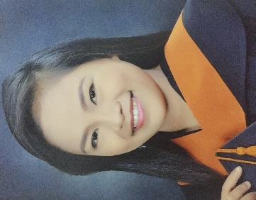

Objectives
To enhance my knowledge in the field of Electronics and Communications Engineering through career exposure that will challenge and strengthen my educational and professional skills and at the same time serve my employer/s very well.

Education
BS in Electronics and Communications Engineering
Polytechnic University of the Philippines (PUP) 2009 – 2014
Brgy. Tagapo, Sta. Rosa, Laguna

Thesis: Application of Proportional Pressure Control Valve In An Air Muscle Actuated Robotic Elbow For Speed Control

Personal Information
Full Name: Fairy Nickname: “Faye”
Birth date: June 8, 1992
Height: 5’ Weight: 106 lbs
Birth place: Cabadbaran Agusan Del Norte
Civil Status: Single

Experience:
Test Hardware Engineer (November 23, 2015 – February 18, 2018)
EMS Resources Technology Inc. serviced at: Maxim Integrated Philippines (General Trias Cavite)
- Evaluate and analyze Data gathered
- Performs component level debugging on Hardware
- Performs simple software debugging on C++ or Visual Basic Environment
- Interprets Hardware schematics
- Trains and coaches technicians on technical issues.
- Regularly communicates with direct supervisor.
- Knowledgeable on basic product test methodologies
- Enforces 5S and work safety standards at all times
- Works with initiative and sense of urgency
- Uses engineering approach on solving hardware issues and applies corrective actions
- Establishes priorities, work independently and carries out objectives with minimal supervision
- Knowledgeable in Microflex and Eagle Tester.
- Perform root cause analysis in the repeatable issue on the hardware.

Engineer – Slider Equipment Department (December 15, 2014 – November 13, 2015)
TDK Philippines Corporation (TPC)
- Responsible in meeting KPIs (Uptime, DGR, MEMS/Disk Life)
- Ensure that tool ramp target will be met on time
- Collaborate with related functions and/or stakeholders to assure each running tools are performing according to expectations
- Generates KPI Report and sets action plans for further improvements
Skills
- English Proficiency: Communication, Technical Writing and Documentation
- Computer Literacy: Microsoft Office , COMPUTER LITERATE
- Special Computer Skills: Photo Editing using Adobe Photoshop
- Basic Programming: C++, Visual Basic (applied in debugging HW)
- Computer Applications: Livewire, PCB Wizard, Proteus, Electronic workbench Multisim,
Circuit Designing, AutoCAD
- Troubleshooting
- Electronics

Able to learn quickly, demonstrate flexibility and persistence. Dependable, analytical and hardworking; Can work well both independently and as a team.

Seminars and Trainings Attended
(Nov 23, 2015- Feb 29,2016)- EMS Resources Technology Inc. Bldg.
- General Engineering
- Test Product Engineering Specialization
- Test Product Focused Specialization

Awards Received
- Best in Project Presentation
- Special Awardee for showing dedication towards work
- Passed in Licensure examinations for ECT
I hereby certify that the above information is true and correct to the best of my knowledge and belief.

