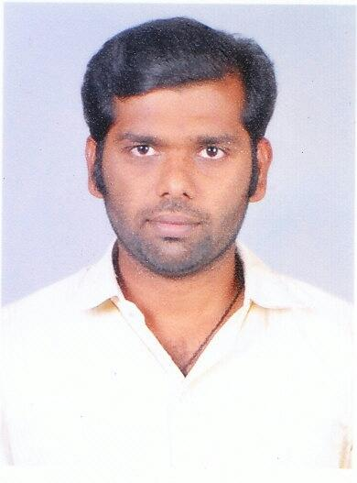
JEYASTON

e-mail: jeyaston.380088@2freemail.com

OBJECTIVE

Toachieveachalengingopportunitiesinrelevantfieldwhere myproblemssolvingandapplicationknowledgeandskilcanbeputinfor thesuccessfulcompletionoftheprojectandgrowthoforganization,which enhancesindividualtalentandcreativity.

PROFESSIONALEXPERIENCE:-
Having 6 Year's experience in the field INSTRUMENTS
CALIBRATIONENGINEER.

ACADEMICQUALIFICATION

D.E.C.E

         SamuelPolytechnicColege,Tuticorin.

H.S.C

         CaldwelHigherSec.School,Tuticorin.

S.S.L.C

         LitleFlowerRCHighSchool,Tuticorin

BRIEFPROFILE

6Year'sexperienceasaInstrumensCalibrationengineer Location.HavingastrongTechnicalandbroad-basedbackgroundwith extensiveknowledgeofvariouswhileworkingwithOrganizationengagedin

thefieldofPowerPlant,Refinery,Reliance,HPCL,ALSTOM,BOC,Offering commitmendandinterpersonalSkil,wiltoworkanywhereintheworld.

WORKEXPERINCE

NameoftheCompany:M/SPerfectCalibrationCenterPvt.Ltd,
Designation :CalibrationEngineer(Lab&OnSite),
Duration :Jun2016toDec2017

JOBRESPONSIBILITIES:

- CalibratingThermal&Electrotechnicaland MechanicalParameterInstruments.

- CalibrationofPressureandVeccumGaugeand
switch.

- CalibrationofMassandDimensionalInstruments.

    CalibrationofVoltmeter,Ammeter,Temperature controler,TemperatureindicatorandTemperatureRecorders,MultiMeter, ClampMeter,Resistance,

- CalibrationofThermocouple,RTDSensor,
Chamber,Furnace,Oven,Thermohygrometer,

- CalibrationofPressuregaugeandTransmiter,
Vacuumgauge,CalibrationOfMass.

NameoftheCompany:M/SPremierInstruments,
Designation :CalibrationandServiceEngineer(Lab&OnSite)
Duration :Feb2011toFeb2016

JOBRESPONSIBILITIES:

         MaintainingQualityRecordsandDocumentswhich folowsNABLSTANDARDISO/IEC/17025:2005.

         CalibratingThermal&ElectrotechnicalParameter Instruments.

         HandlingHighAccuracyStandardInstruments.

         ManufacturingandServicingof“HeatingAutomatic ControlPanelsAndThermocoupleAtachmentUnitandTemperature Recorders.

         AtendingmoretoursinaloverIndiaforOnSite CalibrationandService.

         CalibrationofVoltmeter,Ammeter,Pressuregauge andTransmiter,Temperaturecontroler,Temperatureindicatorand TemperatureRecorders(RRANDCHINO),Thermocouple.

NameoftheCompany:REFFCOEngineering,Tuticorin

Designation :ElectricalTechnician.

Duration :Jan2010toJan2011.

JOBRESPONSIBILITIES:

         maintenancetotemperaturethereefer(A.C. containerbox)

         Loadingandunloadingthereefer(A.C.containerbox) theship.

NameoftheCompany. :Excelcomputercenter,Tuticorin.
Designation :Engineer.
Duration :November2008toNovember2009

JOBRESPONSIBILITIES:

    PCAssemblingandSoftwareInstalation

TYPEOFMASTERINSTRUMENTOPERATING

YokogawaCalibrator(ModelCA71) YokogawaCalibrator(ModelCA12).
EurotronCalibrator(ModelMicrocal2000+)AgilentDMM(Model34410A).
PicotestDMM(ModelM3510A). SanwaDMM(ModelPC5000).
PressurePump(ModelTP1-40(HANDHELDTESTPUMP)).
Universalcalibrator(ModelMECO90A). AiopCalibrator(Cal50).

FlukeMultiproductCalibrator(5520A).

COMPUTERSKILL

   C++,MS-Office,Word,Excel,Powerpoint.

   HardwarePCAssemblingAndSoftwareInstalation.

CO-CURRICULARACTIVITIES

         

          HaveatendedtheworkshoponTemperatureand

HumidityCalibrationinElectronicsRegionalTestLaboratory,Mumbai.

   HaveatendedtheworkshoponCalibrationTechniquesin

ElectronicsRegionalTestLaboratory,Mumbai

   HaveundergonetraininginCalibrationTechniquesand

UncertaintyCalculationforThermalCalibrationatTempsens,Udaipur.

          HaveundergonetraininginCalibrationTechniquesand

UncertaintyCalculationforThermal&ElectrotechnicalCalibrationatPerfectCalibration

CenterPvt.Ltd,Chennai.

PERSANALSKILLS

 Selfconfidentandhandlingcorrespondenceof responsiblematers.

- Setmotivatedandcapableofinitiatingnewidea andself-learning.

Sincereapproachinducteesandresponsibities. Abilitytoworkunderpressure.

Happiness

         Sport(ciricket),

PERSONALDETAILS

DateofBirth :31.08.1989

Sex :Male

Nationality :Indian

Religion :Christian

LanguagesKnown
 Read,writeandspeak :Tamil,English.
 speakonly :Hindi,Malayalam.

DECLARATION

Iherebydeclarethattheaboveinformation’saretruethebest
ofmyknowledge.

