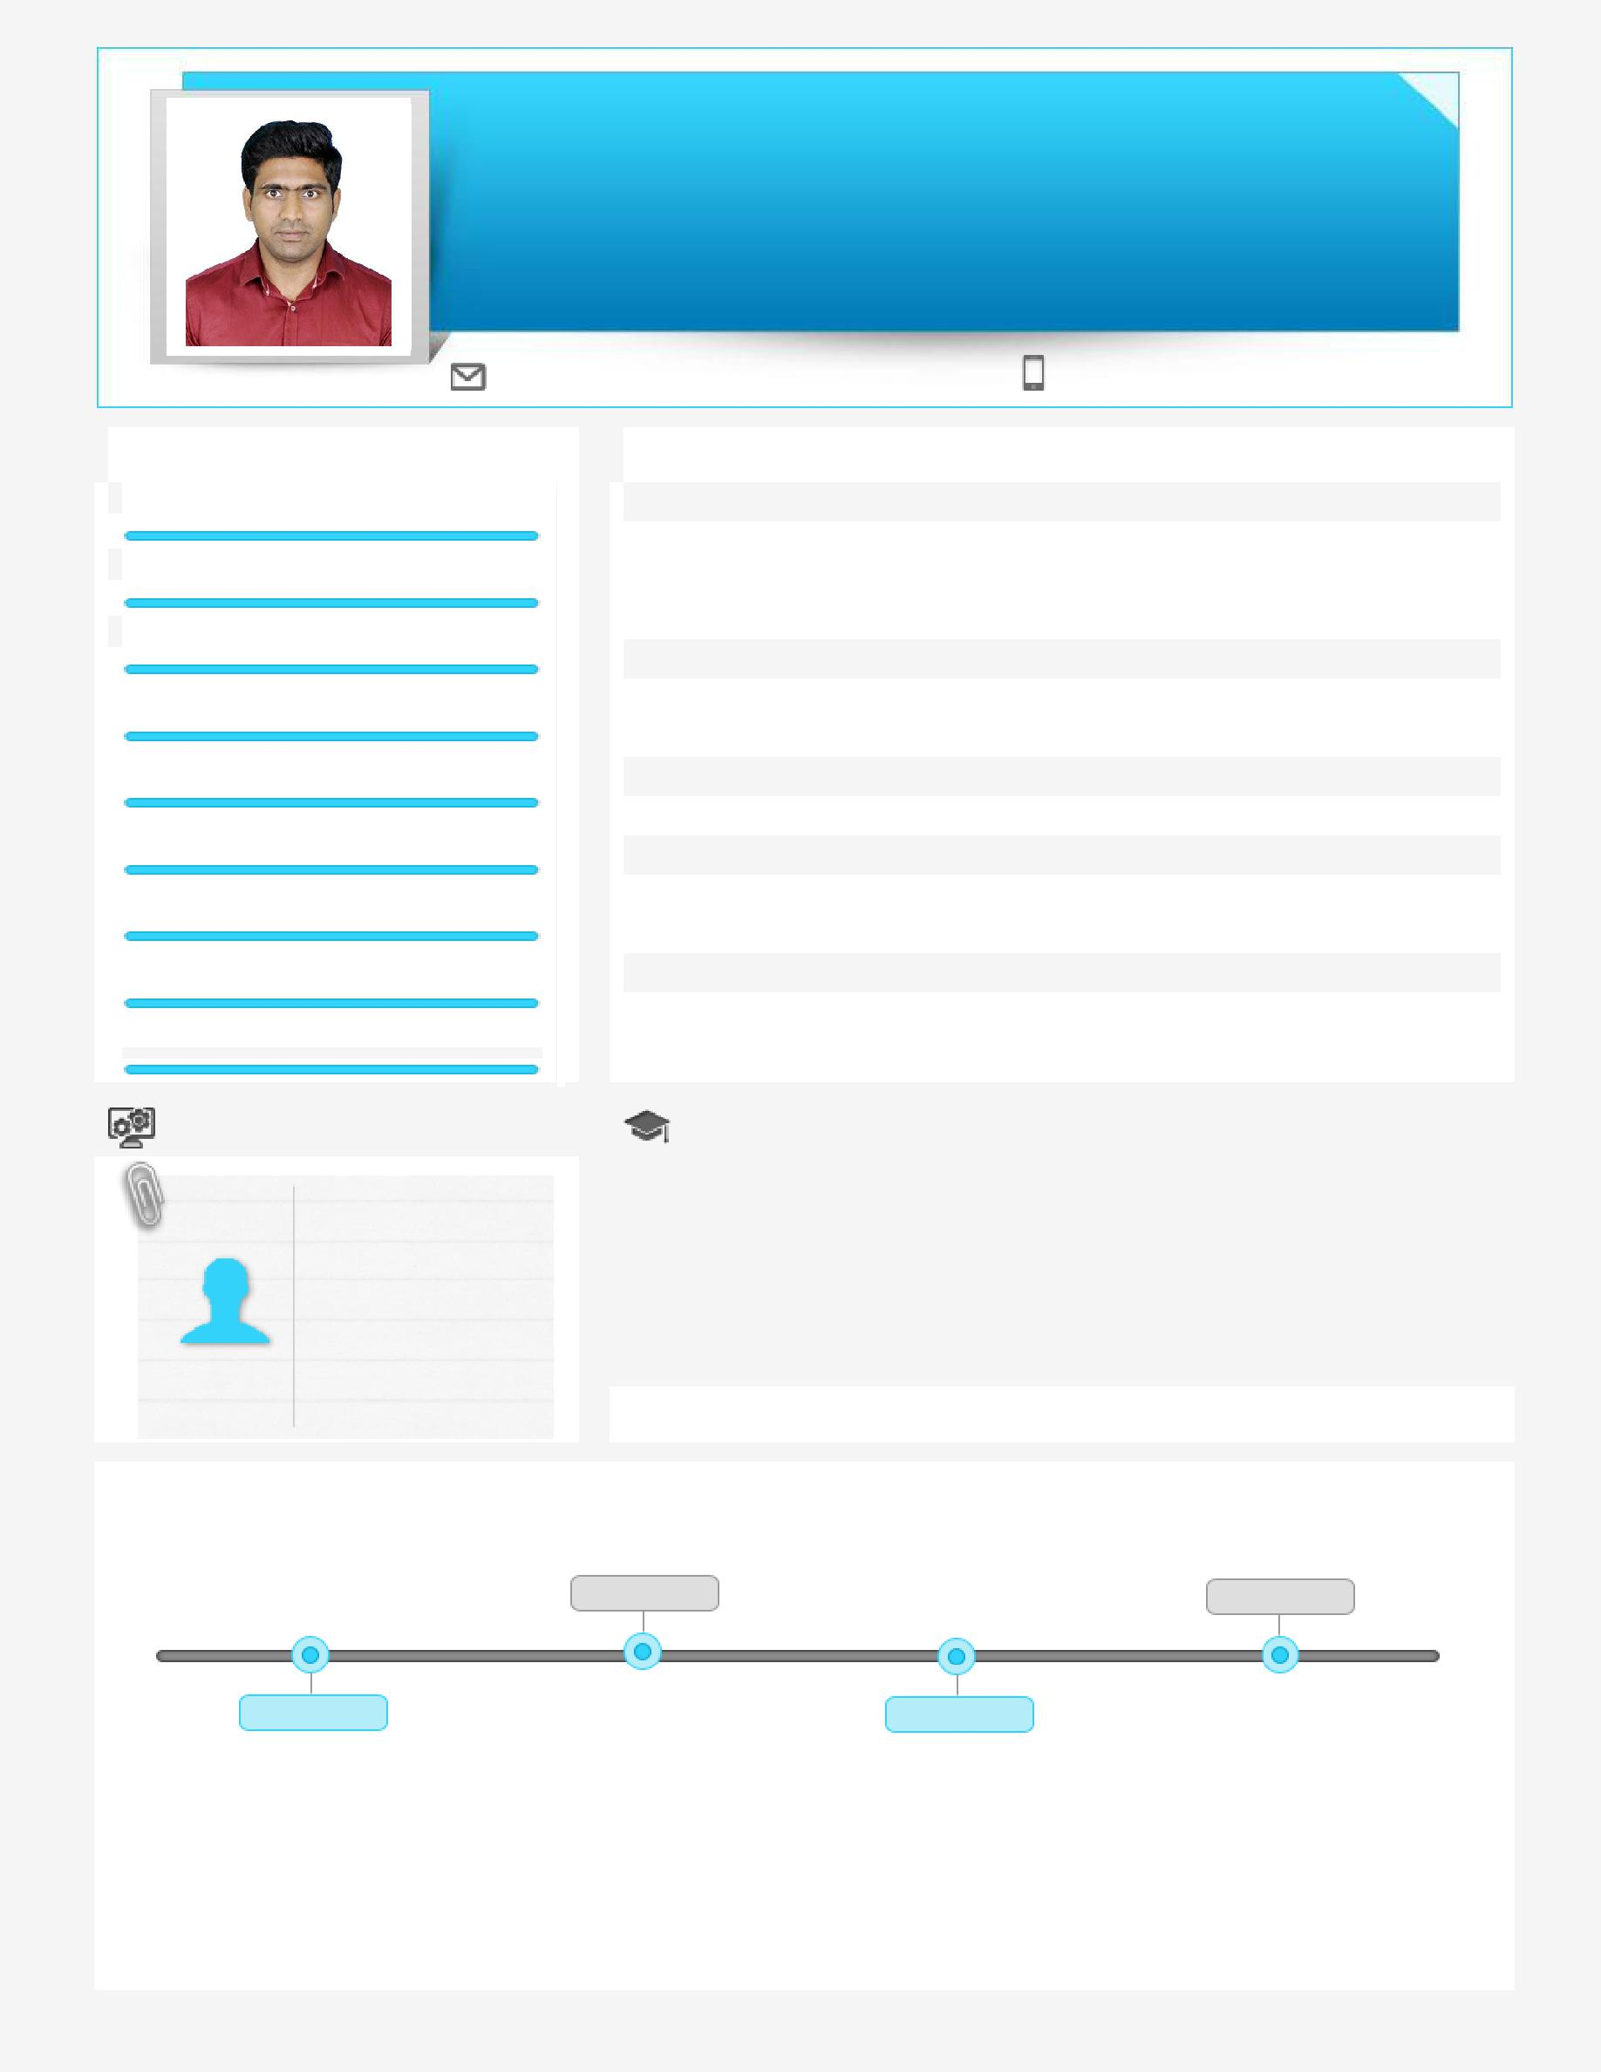
BESTO

Project Engineer/Designer

Vertical Transportation Systems

Location Preference: UAE

Best.380089@2freemail.com

Key Skills
VT systems Operation Installation & Commissioning

VT systems Design Project Documentation Site Management

Client Relationship Management

Trouble Shooting

Training & Development

Team Building & Leadership

Profile Summary

- Result-oriented professional with over 7 years of experience in vertical transportation systems operation, new equipment installation and commissioning, Client Relationship Management, AutoCAD VT systems design drawings and information, Project documentation

- Skilled in implementing the preventive & predictive installation schedules for improving the overall reliability and safety of equipment & machinery

- Hands-on experience in installation and commissioning of vertical transportation systems

- Proficient in directing productive cross-functional teams using interactive and motivational leadership that spurs people to willingly give excellent results

- An enterprising leader with skills in leading personnel towards accomplishment of common goals

 | Soft Skills |  |  | Education
 |  |  |  | • 2013: Designing & Planning Software Courses from CADD Centre, Noida
 | Team Activities |  |  | • 2011: Advanced Diploma in Embedded System Programming, ISM
 |  |  |  | Institute, Chennai
 | Communicator |  |  | • 2011: B.Tech in Electronics & Communication Engineering, SASTRA
 |  |  |  | University, Trichy
 |  |  |  | • 2007: Higher Secondary Certificate, Erode
 | Planner |  |  | • 2005: Secondary School Leaving Certificate, Aruppukottai

Initiative

Career Timeline

Johnson Lifts India Limited, Noida as |  | Mitsubishi Elevators,
 |  | Bangalore as Project
Engineer - Operations | 2014-2015 | Engineer | 2016-2018
2011-2014 | Schindler Elevators India Limited, | 2015-2016 | Lerch Bates Inc, Dubai as VT
 |  |  | systems Designer
 | Gurgaon as Project Engineer

Trainings Attended
• Schindler “S3300 IN / S5300 IN Installation & Commissioning Training” • Customer Centricity program
• Site safety risk analysis training

Work Experience
Feb’16 to Feb’18 with Lerch Bates Inc, Dubai

Designer (VT Systems)

Role:
- Review the project program to establish vertical transportation design requirement with the architect

- Provide vertical transportation design drawings and information for the arrangement of the equipment application

- Design will confirm with prevailing codes directly related to the equipment application selected

- Update and coordinate vertical transportation information based on specific communication from the architectural team which affects the vertical transportation equipment

Jul’14 to Jan’16 with Schindler India Private Limited, Gurgaon Project Engineer (New Installation)

Role:

- Responsible for installation and commissioning of schindler product 5400 MMR and product 5500 MRL –Suspension traction media

- Certified in schindler product “S3300 IN / S5300 IN” (MRL –Suspension Traction Media) scaffold less installation & commissioning
- Responsible for planning, scheduling, supervision and controlling the task of installation & commissioning project

- Schedule the various jobs and complete the monthly Projects as per the targets within estimated costs/agreed time schedules and as per the Safety and Quality standards

Jul’11 to Jul’14 with Johnson Lifts Private Limited, Noida Project Engineer (Operations)

Role:
- Supervise the erection sites, monitor and follow-up on the installation process

- Maintain a communication channel with customers for resolving and closing the issues

- Documentation of all key activities in accordance with all contract conditions and to company’s procedures

- Responsible for administrative activities of the project including daily human resource management (absences, time sheet review/approvals)

- Develop and maintain a cordial and professional relationship with the subcontractors

Technical Skills

- Operating System: Windows

- Programming Languages: C, C++, Ladder Logic, FBD (Functional Block Diagram)

- Software: AutoCAD, Engineering Base, MS Office

Extracurricular Activity

- Performed as Event organizer in symposium held in college

Personal Details
Date of Birth: 11th April 1989
Nationality: Indian
Marital Status: Married
No. of Dependents: Nil
Visa Status: Visit
Driving License Details: UAE, India
Languages Known: English, Tamil and Hindi

